Contents

First web-based approach – Python Flask and Bootstrap: 3

Why I decided to change from a GUI to a Web Application: 3

Creating a virtual environment using pip: 3

Installing all modules and dependencies for the web application: 3

Creating the directories and files for the program: 4

Setting up the website directory: 4

Creating the files that will be needed for the application: 4

Setting up the application: 5

Creating the views: 5

Creating the base template: 5

Base.html: 5

Home.html: 6

Registering the blueprints to the application: 6

Updated version of “__init__.py”: 6

Running main.py to check everything is working and initialised properly: 6

Creating the login page (front-end): 6

Adding some extra pieces to “base.html”: 6

Second web-based approach – Python Flask and TailwindCSS: 7

Why I decided to change from bootstrap to tailwind: 7

Preparing the workspace: 7

Creating the virtual environment: 7

Entering the virtual environment: 7

Installing the python packages needed: 7

Creating the files and directories I need to begin this application: 7

Installation and Setup of TailwindCSS: 8

Setting up the main CSS file to inherit Tailwind’s classes: 9

Building the application: 9

Initialising the Flask Application: 9

Creating a test blueprint: 10

Building the home page: 11

Setting up the route: 11

Start of development based on designs: 11

Building the Login Page: 33

Preparing the head tags: 33

Creating the navigation bar: 33

Adding the side image + text 34

Adding the login form, and other text on the left: 34

Adding the login form: 34

Handling POST requests: 35

Adding a new participant: 35

Deleting a participant: 37

Adding a score to a participant: 37

Creating a new event: 38

Editing and deleting an existing event: 38

Handling Login Requests: 39

Logging Out: 39

# First web-based approach – Python Flask and Bootstrap:

This section documents my first initial approach to a web-based application using python’s flask and the CSS framework called bootstrap. This method didn’t make it past the initialisation stage, the reasoning behind this will be explained later on in the document.

## Why I decided to change from a GUI to a Web Application:

I took the decision to change my project from a GUI-based application to a Web-based application because with a web-based app you are offered a lot more freedom in terms of design and features in my opinion. For example, the HTML and CSS aspects alone of the web application allow for great design opportunities compared to that of a pythonic GUI. Furthermore having the ability to merge HTML, CSS and JS with Python allows for many more front-end features for the application which benefits the overall user experience whilst using the application and also provides support for all devices, since it will be accessible via a browser rather than a python script and/or executable.

## Creating a virtual environment using pip:

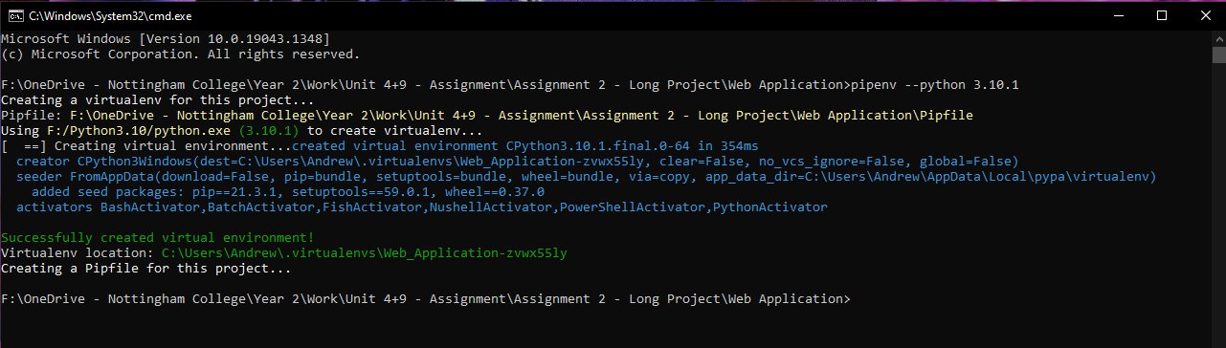First of all, I create a virtual environment by opening command prompt in the directory I’m going to be making the web application in and write the command “pipenv –python 3.10.1” to create a virtual environment in python version 3.10.1.

## Installing all modules and dependencies for the web application:

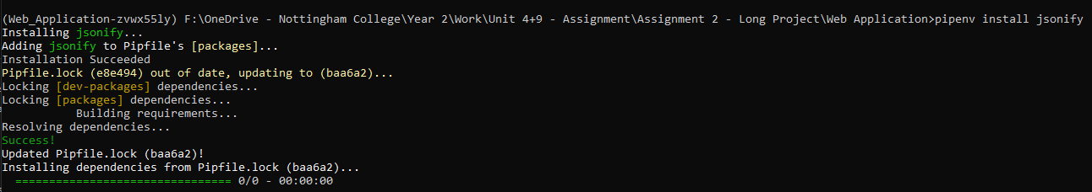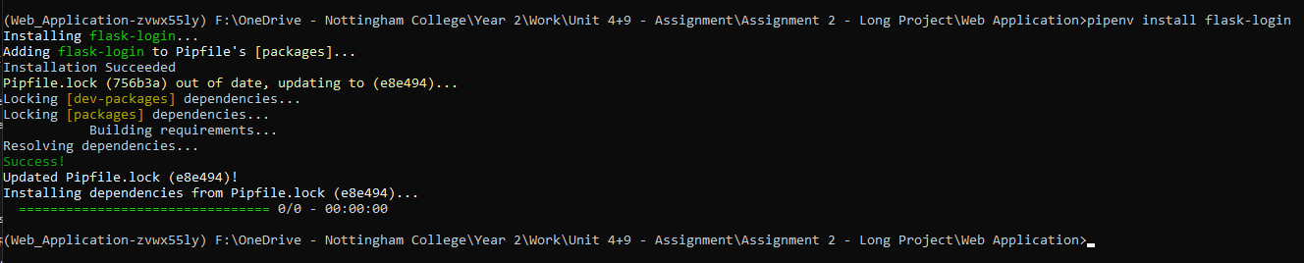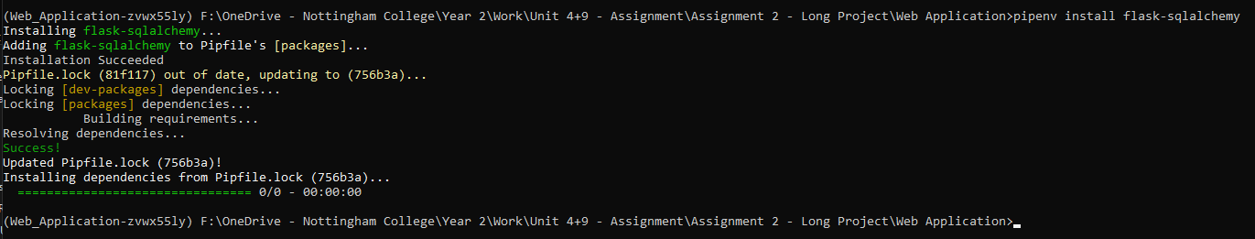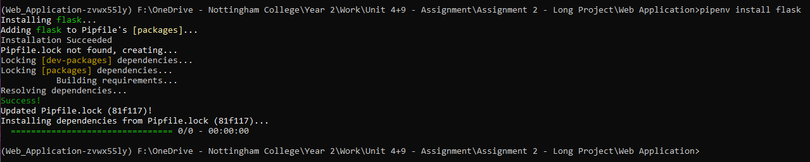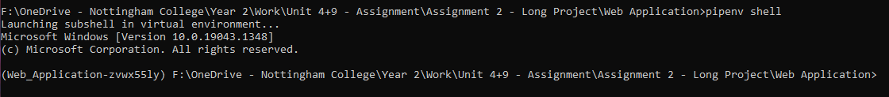Up next I need to install all of the modules I will be using for this application. To do this, I start a shell within the virtual environment and install everything as seen below:

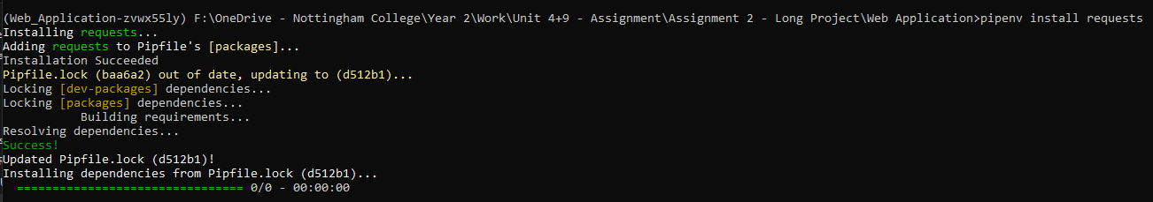

## Text Description automatically generatedCreating the directories and files for the program:

To begin with, there are 2 things that need to be created before doing anything else. I need to create the “main.py” file which is the file that will be run and starts the entire web application up, and the “website” directory which will contain the main bulk of the code for the application itself. Also after creating the virtual environment and installing the dependencies, there are 2 files already in the main directory called “Pipfile” and “Pipfile.lock” which contain details on the environment such as packages and version requirements etc.

## Text Description automatically generated with medium confidenceSetting up the website directory:

For the website directory, there are a few sub-directories that I need to make which will all contain the front-end elements of the application (HTML, CSS and JS). These sub-directories will be called “templates” and “static”. Furthermore, inside the “static” sub-directory there will be 3 more sub-directories each called “styles” for CSS files, “js” for JavaScript files and “img” for any images. This sub-directory is called “static” because they contain static files, these files should not be changed at all once deployed. Additionally, the sub-directory “templates” speaks for itself in terms of its naming, you create templates which you later render in the python files which will be displayed later on in development.

## Text Description automatically generated with medium confidenceCreating the files that will be needed for the application:

This is where I create all of the python files which make the web application function, as well as all of the front-end files that the python files will render and utilise once the python functions have been written. The “__init__.py” file contains all of the main configuration and the setup of the application. The “auth.py” file will contain all of the code that makes the login function work, and handles requests from the login form that will be written in the front-end files, and again rendered by the python functions. The “database.db” file is as said in the file name, the database for this web application, now because this database is local it may pose as a security threat, however since the vital data such as a user password will be encrypted it won’t be an issue. The “models.py” file will contain the database classes that will be called in “auth.py” which allows us to write to the database. The “views.py” is essentially the same as “auth.py” however instead of containing the database functions and handling requests, its simply there to handle the rendering of the templates found in the front-end files. Finally, the front-end files that will be used and explained later on are “base.html”, “home.html”, “login.html”, “styles.css” and “main.js”.

## Setting up the application:

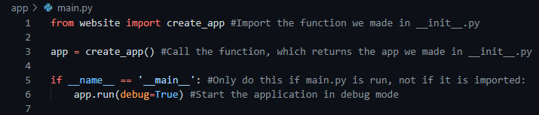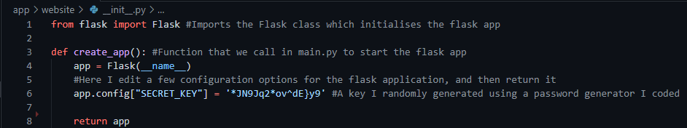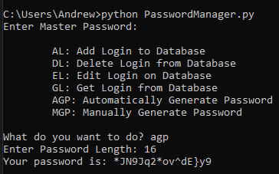This is where the actual back-end coding begins. The first file that will be written to is the “__init__.py” file, we need to initialise the application and some other things later on (because they aren’t need right now). Most of what is going on will be explained through comments in the screenshots provided below. The terminal screenshot displays the password generator I used for making the secret key for the application.

## Creating the views:

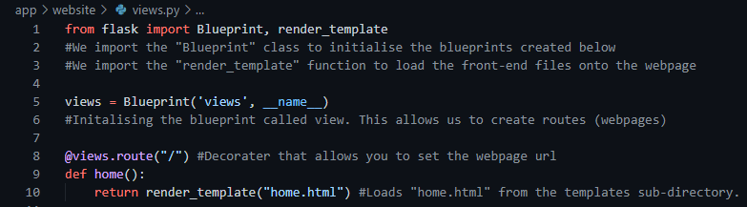When it comes to Flask and web applications in particular, I need to create views that perform functions, their main use is to handle requests on specific pages and return a render template function that displays the front-end of the web page.

## Creating the base template:

When using python alongside html for a web application, you have the ability to write python-like code within the html files, this is specifically useful for creating blocks and using variables from the route functions. The blocks are best useful for creating base html files which act similar to a template, as shown below.

## Text Description automatically generatedBase.html:

## Text Description automatically generatedHome.html:

## Registering the blueprints to the application:

In order to utilise these blueprints (views), we need to register them in the “__init__.py” file, by doing this I import the “views.py” file and insert it into the “register_blueprint” function alongside its “url_prefix”. How that is done can be found in the screenshot below.

## Text Description automatically generatedUpdated version of “__init__.py”:

## Graphical user interface, application Description automatically generatedRunning main.py to check everything is working and initialised properly:

Up until now, after the first time running the main.py file, what we should find is the page title is “Home · College Tournament” and not “ · College Tournament”, and we should see a h1 header saying “Hello World!”. This is the result after running main.py and viewing the website on localhost.

## Creating the login page (front-end):

Since this application will only be available for the teachers to update, we need to have some kind of restriction in place to ensure students can’t get access to the website and alter scores and entities’ (teams or individuals) data. This will be in the form of a login page, with no signup option available (the login details will be pre-defined in the database) that only teachers will know and have access to. This will be a stylish but simple login form that any user will be prompted with, and the home page route and any other route we create within the application will use a special decorator that only allows logged in users to view. The screenshots below are showcases of the front-end code alongside some explanations of what certain pieces actually do and why I have used it.

## Adding some extra pieces to “base.html”:

The first element that I will be adding to the base is a navigation bar, this will later have some alterations to make the navigation and names cleaner and more concise but that will only be available to us once the login page, both front and back-end are complete.

# Second web-based approach – Python Flask and TailwindCSS:

## Why I decided to change from bootstrap to tailwind:

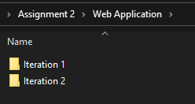Just before I was about to fully commit to the front-end of this application, I actually discovered a better CSS framework that I could use that would benefit me more for this project in particular, called TailwindCSS. Despite this framework being more compatible with JS-based frameworks such as Vue, it is still applicable to a pythonic applications. The main feature of Tailwind that appeals to me and this project more than Bootstrap does, is the fact that Tailwind provides much better customisation and also has a few other features such as a VSC extension providing “intelli-sense”, making development easier, and better utility classes.

## Preparing the workspace:

Before creating this, I am keeping the first and current iteration of this project in the same directory, just separating them into 2 sub-directories to keep them in the same place. The previous iteration being named “Iteration 1”, and the second (current) iteration being named “iteration 2”.

### Creating the virtual environment:

For this iteration, I have changed from using “pipenv” for the virtual environment to “venv”. This serves the same purpose as Pipenv however it is easier to use.

### Entering the virtual environment:

To enter the virtual environment, it is extremely simple. I just need to run the command “CollegeWebApp\Scripts\activate” and I will be inside the virtual environment, completely ignoring any other packages I already have installed on my machine. You can tell that you have successfully entered the virtual environment when the name of the environment is in brackets to the left of the directory location in command prompt.

### Text Description automatically generatedInstalling the python packages needed:

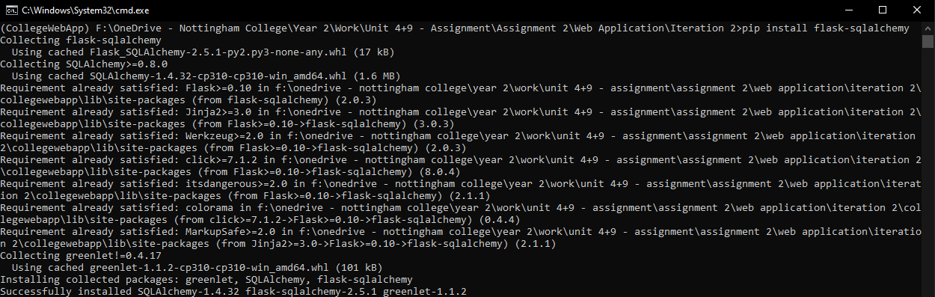Installing the required python packages is extremely simple. The command is simply “pip install <package_name>” and this will fetch the package from something called PyPi and install it to the virtual environment for me to use in my application. The packages I need to install for this project are the following:

* Flask
* Flask-login
* Flask-sqlalchemy

Note how I only install flask-login and flask-sqlalchemy. Since Flask itself is a dependency of both of these packages, they will automatically install Flask, and a few other dependencies if they are not present in the environment they are being installed to, removing the need for me to install Flask separately.

### Creating the files and directories I need to begin this application:

To begin with, there are only a few files and directories I need to make to have the structure of the application initialised. To begin with, to separate the application from the virtual environment that I created called “CollegeWebApp”, I will create a directory which will act as the application’s “root” directory called “app”. This will contain all of the files relating to this application. 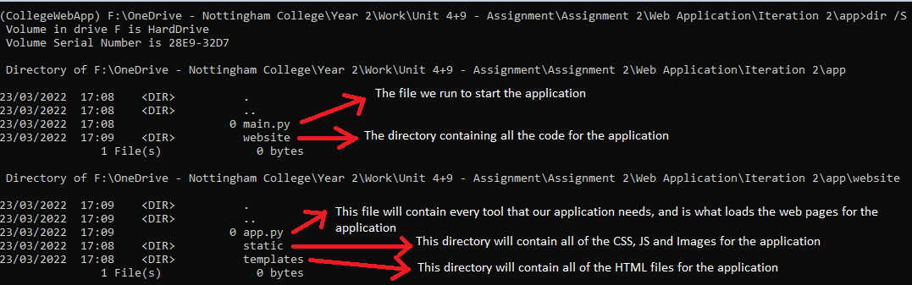

Using the windows command “dir /S” will display every file and directory inside the directory you run the command in. The screenshot above displays the root directory’s contents at the top, as well as the contents of the “website” directory at the bottom, all of which are accompanied with an explanation on their purpose for this application.

### Installation and Setup of TailwindCSS:

**IMPORTANT NOTE:** Node.js is required for the installation of TailwindCSS.

From this point onwards, any terminal usage I’ll be doing inside the built-in terminal on my IDE, Visual Studio Code (VSC).

First of all, once node.js is installed I need to install the CSS framework I’ll be using for this project, TailwindCSS. I can do this by running the following in the terminal.

“Added 96 packages” shows us that tailwindcss has been successfully installed, and to double check, I can check the newly created “node_modules” directory in my workspace and check for the “tailwindcss” sub-directory, which is shown to the right.

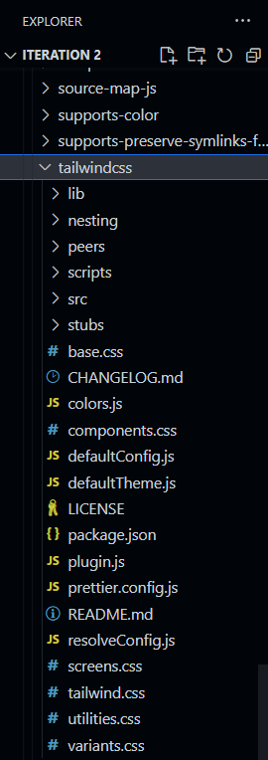

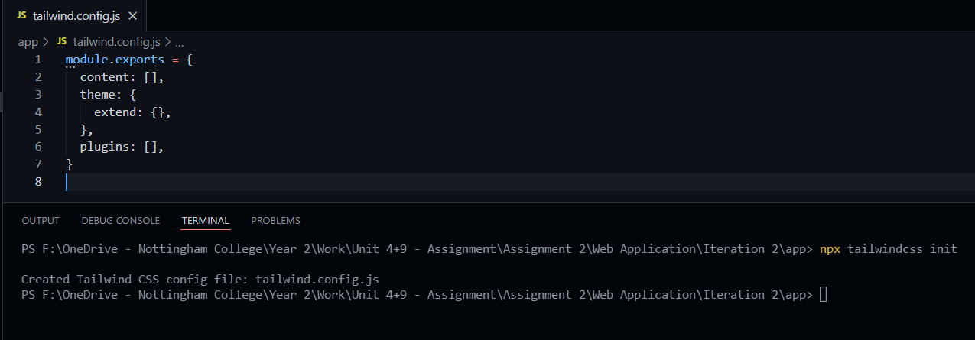Next I need to generate a configuration file for tailwind. Features like this in particular are what made Tailwind a more favourable option over bootstrap, its flexible configuration and vast amount of utility classes. Running “npx tailwindcss init” creates a file called “tailwind.config.js” which is where any configuration for tailwind will take place.

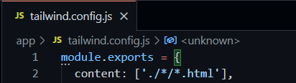

To finish off initial configuration, I just need to insert the file location of all of my template files, these being the HTML files. The screenshot below shows this.

### Graphical user interface, text, chat or text message Description automatically generatedSetting up the main CSS file to inherit Tailwind’s classes:

First of all, I need to create the CSS file that will be holding all of tailwind’s classes. I will be creating a file called “input.css” in the “website/static/styles” directory and adding 3 short lines of code that when they are run, will import all of Tailwind’s classes.

Finally, in order to have these classes imported, I need to run the following command in the terminal: “npx tailwindcss -i ./website/static/styles/input.css -o ./website/static/styles/styles.css --watch”

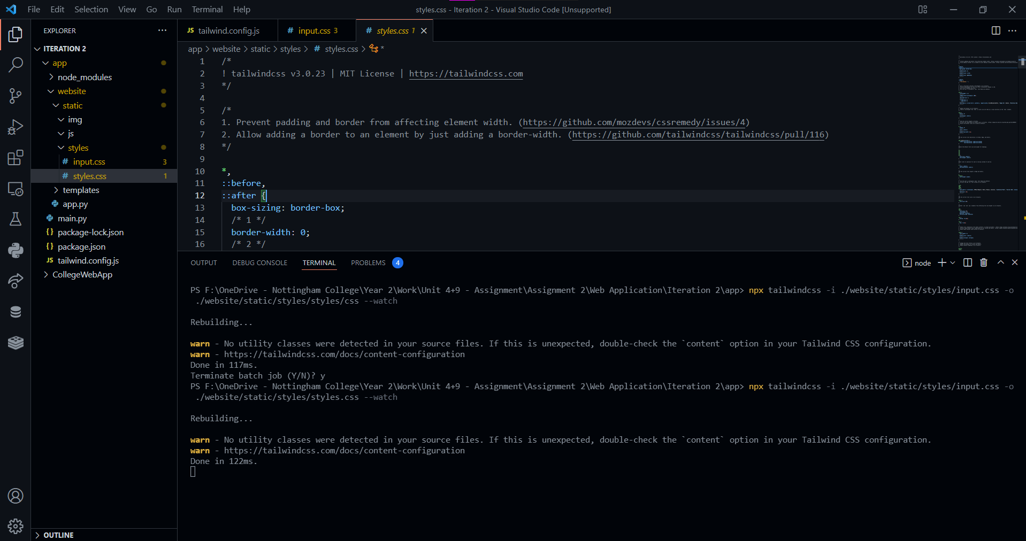As you can see below, the above command has been run and we now have a new file called “styles.css” which now contains all of the imported TailwindCSS classes. “input.css” is no longer needed so that file will be deleted and now the setup of both Tailwind and the workspace environment is complete.

## Building the application:

### Initialising the Flask Application:

The file structure will be slightly different compared to the previous iteration of this web application. Upon doing further research into Flask applications I have discovered better ways to utilise this package and this will be documented throughout this project.

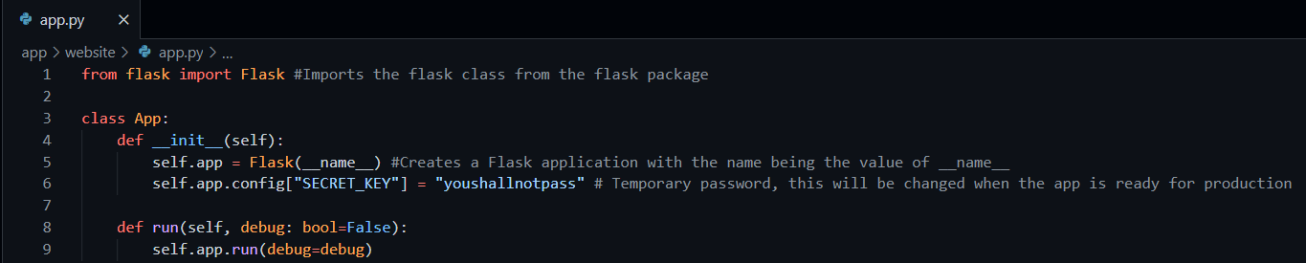To begin with, I need to head into the “website” directory and enter the file called “app.py” which will contain the class that manages the entire application.

This snippet here is the very bare bones, basic initialisation of the Flask application. At the minute this application will do entirely nothing, but can still be run and will create a local development server as seen below.

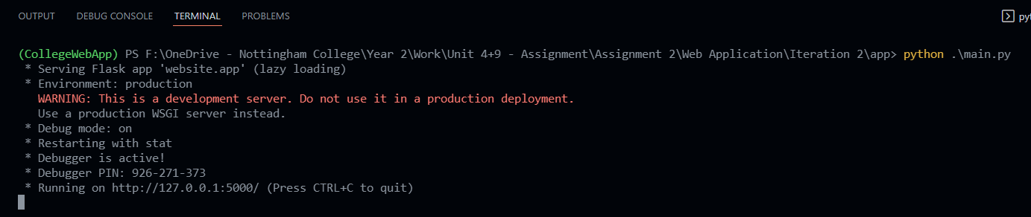

### Creating a test blueprint:

In Flask terminologies, a blueprint is essentially something we register to our application that contains a collection of routes and other app-related functions, a blueprint is simply an object that allows you to define application functions, without requiring the application object (the class I defined earlier inside “app.py”) at the time of definition.

First of all, I need to create a new file called “views.py”, this file will contain a singular blueprint that will handle all web pages that are not related to logging in to the application (log-in page). They will be put in a separate file later on in development of the application. The purpose of each element in the screenshot below is explained with a corresponding comment.

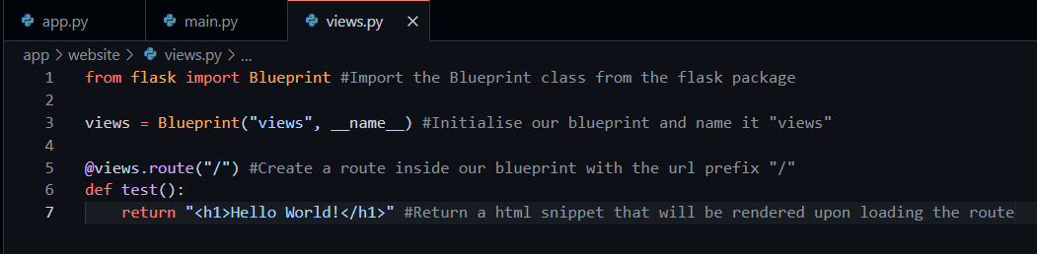

#### Assigning the test blueprint to the application:

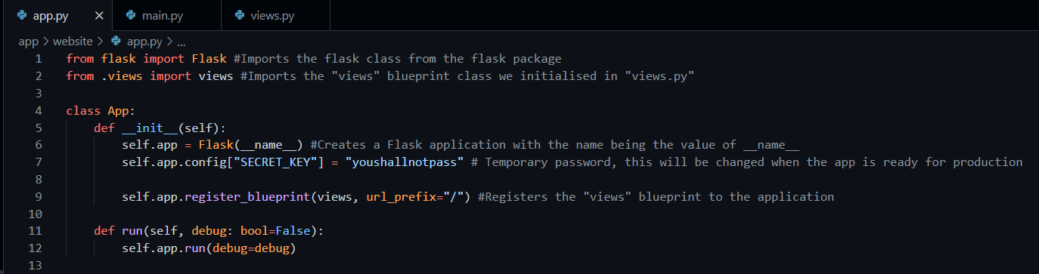

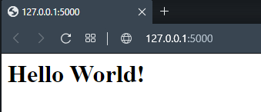Now if I run the application, and go to <http://localhost:5000/> in my browser, it should render the HTML that I wrote in the test function inside “views.py”, as seen below. (Screenshot on the right is from inspect element, to check correct HTML elements have been pushed)

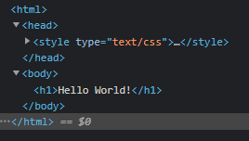

At this point, everything is working as intended, so now it is time to start building the home page, this will also be where we can verify that the installation of Tailwind is properly successful by attempting to use the classes that have been imported into “styles.css”.

## Building the home page:

*\*A full list of tools, and links to them where necessary, can be found near to the end of this document.*

### Setting up the route:

The home page is going to have a number of features, as shown in the designs however like any other project, they are bound to have reworks or changes made to them mid-development. Any changes that are made from the initial designs will be documented and justified towards the end of this document. Before the development of the home page begins though, a “home.html” file needs to be created inside of the “templates” directory, and it needs to be linked to a route inside the newly created “views” blueprint.

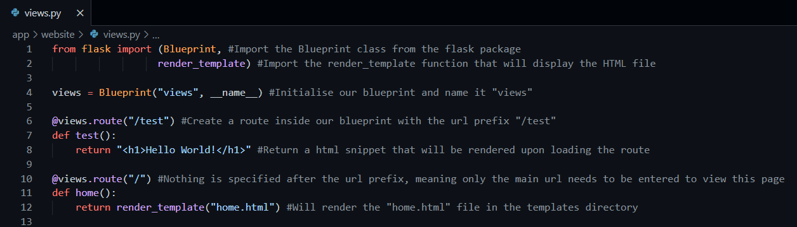

*\*Note: the test route has now been changed to “/test” and home takes “/”.*

To ensure the routes have been switched properly and the new “home.html” template is being rendered, I will add some markdown to the HTML file, differentiating from the html defined in the test function to make sure everything is updated.

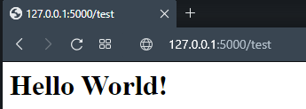A helpful feature from Flask is that I don’t need to stop, and restart the application after every change, since the application is in development mode, it automatically updates the contents of the app after every save of the code. The updated “/” route can be seen in the screenshot on the left, and the usage of “/test” can be seen on the right.

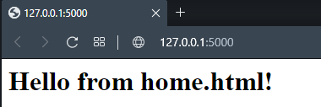

The test function is no longer needed so I’m going to remove that. From now is where the actual HTML based on the designs produced begins.

### Start of development based on designs:

#### Preparing the home.html file:

Before the elements are created, the html file needs some tags and external files to be linked as seen below. You’ll notice that I referenced the CSS file slightly differently than a normal CSS file would be. This has nothing to do with it being Tailwind, it’s actually due to the template tool that Flask uses to render the HTML, called Jinja2. It is also what allows me to use python in the HTML file later. I have also added a stylesheet link to flowbite’s framework as well, since some elements in this project will require some classes that flowbite also has to offer.

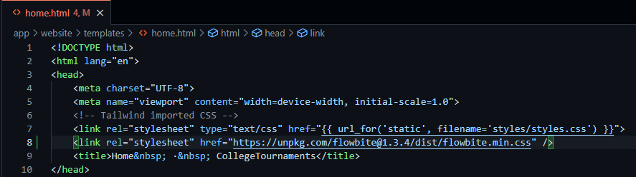

#### Navigation Bar:

This is a preview of the navigation bar in the designs I had produced:



##### Code:

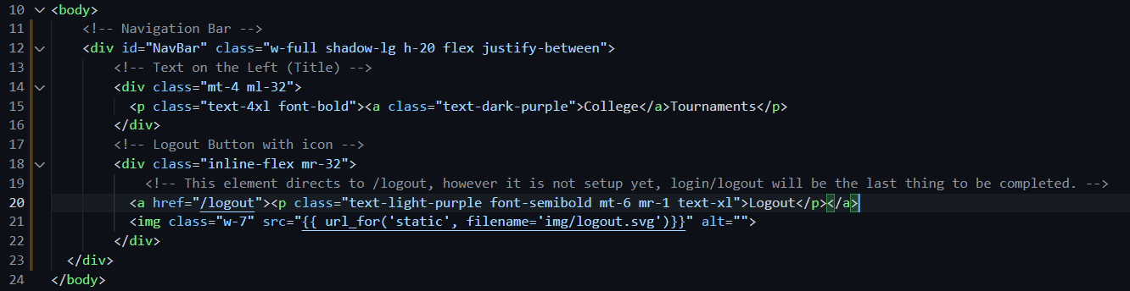

##### Output on browser:



Compared to navigation bars that you would find on most websites, the navigation bar for this project in particular is quite abnormal, since there is only a logout button and no navigation buttons other than that. The logout button currently has no functionality other than linking to a currently non-existent route, the login and logout routes will be created once the main page is complete.

#### Background:

Now that the navigation bar is in place, I can set the background for the div/section underneath it, which in my opinion is a key factor for how clean and appealing the design is. I’ll implement this simply by setting the background-image of the next div to be the image and specifying a pre-defined height that the image will be placed on the website as.

##### Code:



##### Output on browser:

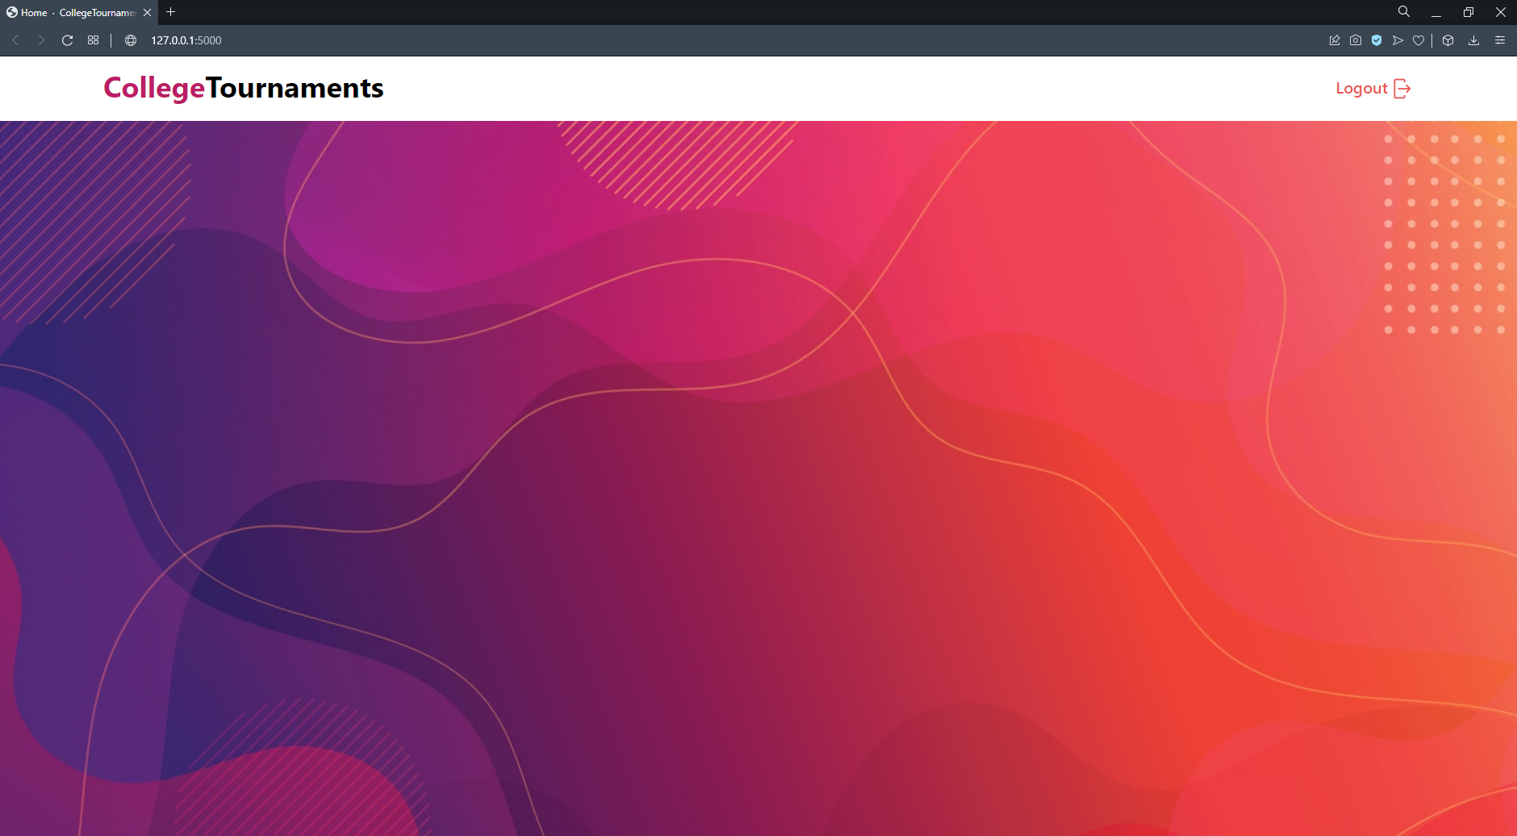

The classes that come with tailwind have made it extremely simple for me to set specific widths for the image such as “w-full” and “h-vh-full”, these 2 classes force the image width to be the full width of the screen, as well as the full height of the screen as well. Furthermore, I have used the “flex”, “items-center” and “justify-center” classes to later allow me to flexibly place the elements onto the page, and have them centred.

#### Dashboard:

The dashboard for this project is the elements in the center of the designs. It consists of 4 cards, and is placed on a white background. Now upon reviewing the design initially, I have decided that the settings panel is no longer needed, since there would be no configuration needed for this web-application since the user can freely zoom in and out themselves with their browser and no other configuration settings would be needed for an application like this. Furthermore, I also decided that there should be a more obvious way to add participants, as well as adding a score to their player data, so after consulting with a peer of mine, they gave me a few recommendations based on the designs I have created, and I will do my best to implement these.

 A few ideas that initially come to mind are the following:

* Move the total participants (currently displayed next to participants title) underneath the title and have it separately show the total of Individuals and Teams, but also have an icon accompanying both pieces of text that allows them to add the corresponding entity (Individual/Team).
* Add a new icon next to the “delete” icon on the participants display tab that allows the user to add a score to that member from an event they just played, rather than having the “Adjust Scores” button hidden in the bottom right where it doesn’t even correlate to the participants.
* The only elements needing to be displayed for the participants tab is the name of the individual/team and an “actions” tab as my peer advised me to do in the feedback he gave.
* Add a dropdown select menu of sorts to differentiate between displaying individuals and teams. Implementing it like this will keep the layout and design the same, and still allow for some kind of clean separation between the 2 participant types. This select menu element would also be implemented on the Leader-board and Events tab.
* Finally, now that the need for the settings tab has been eliminated, I will extend the events tab’s height to be equal to the tabs beside it, and completely remove the settings tab.

##### Getting the background card:

###### Design:

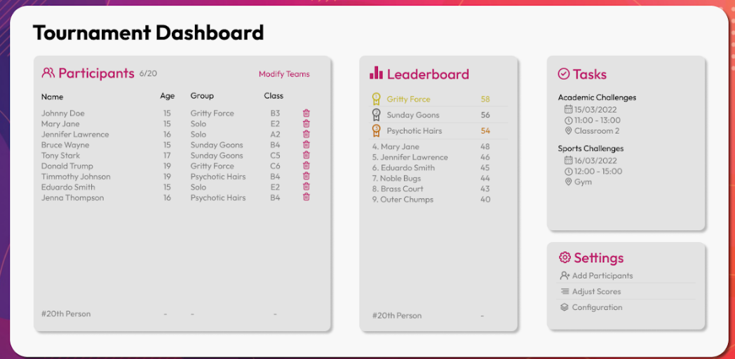

This is the initial design for the dashboard. First of all I need to get the main white background element in place to then put the (now 3) tabs on top of it.

###### Code:



To create the white background, I simply just need to create another div inside the container which has the background image inside of it and add a few classes to it to shape and size the element. For example, “bg-white shadow-2xl rounded-2xl” are what makes this a rounded rectangle with a shadow, “bg-white” is of course what makes it white, and “pl-14 pt-7” adds something called a padding which is what puts the rectangle in the position it’s in. I also went ahead and added the “Tournament Dashboard” title on the top left of the element as well. The classes assigned to the h1 element are simply text sizing, and making the text bold.

###### Output on Browser:

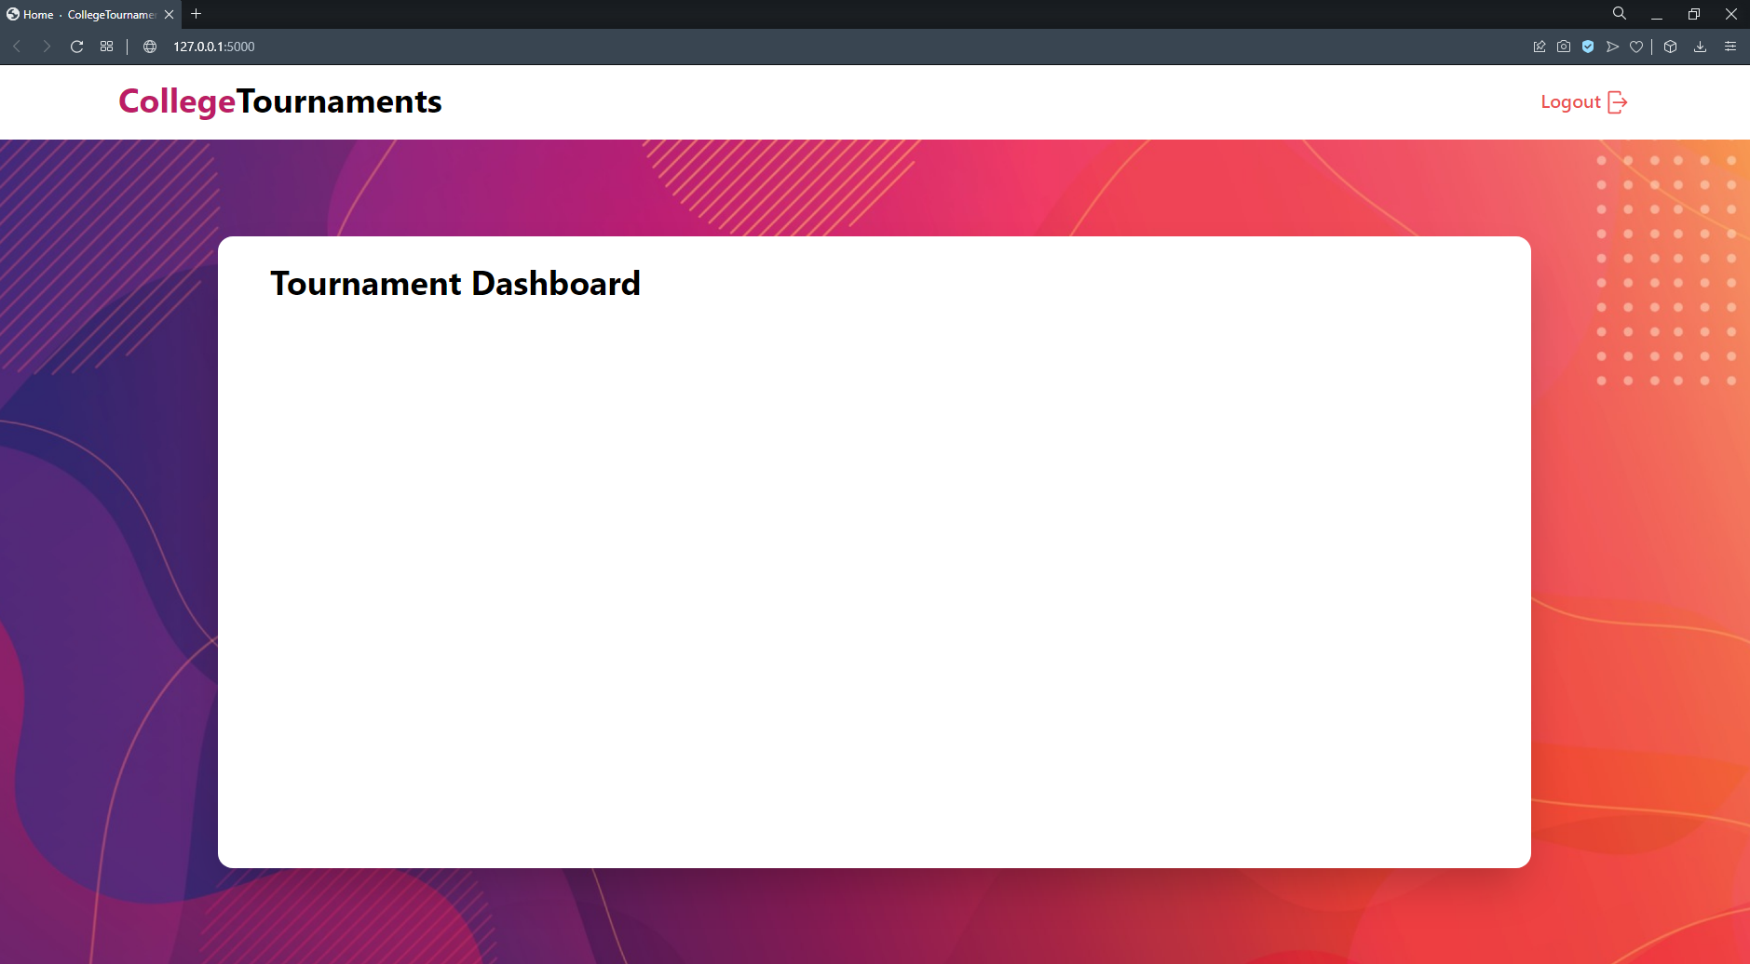

##### Adding the 3 cards on the main card:

First of all, the 3 cards need to have a container that hold all 3 cards in, this container in particular needs to be a flex container and there will be 1 div per card inside this container div.

The only difference in layout between the initial design and what I have produced below is that the settings tab is now gone, and the events tab is full height alongside the 2 tabs to the left of it.

###### Design:

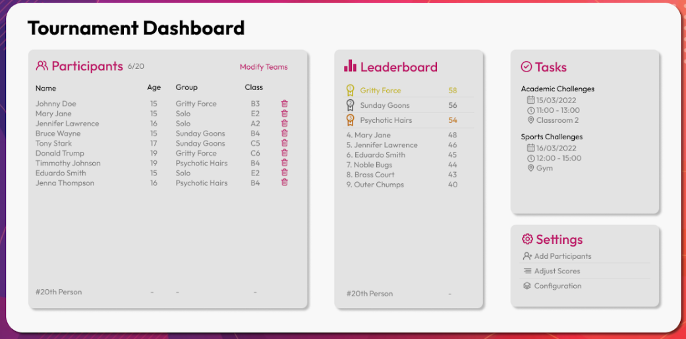

###### Code:

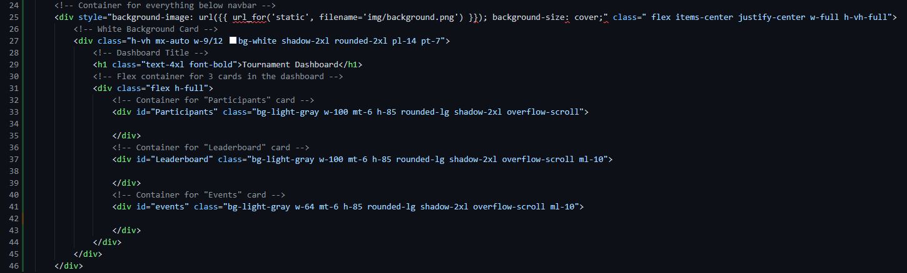

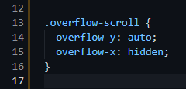I have added some short comments explaining what each div does for readability purposes. I have made it so the divs have a specified width and height, a background colour and a shadow to add a nice visual effect to the dashboard. Finally, the “overflow-scroll” is a custom class I have made myself, which will display a scroll bar, and hide any text that goes outside of the div it is specified in. A real example of this will be shown once I start displaying data on the page.

###### Output on Browser:

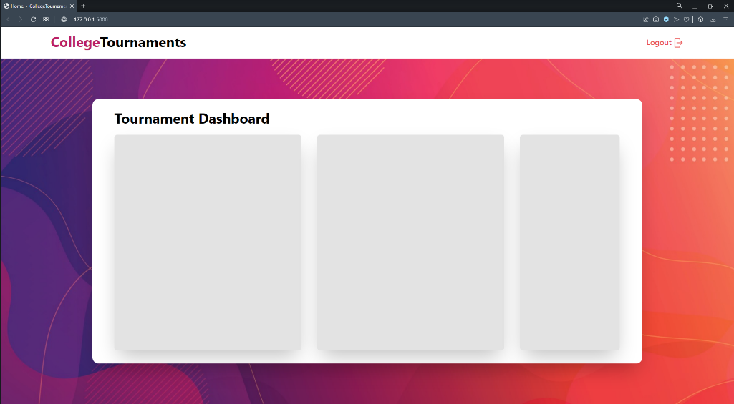

##### Participants Header:

The participants tab is going to be the lengthiest section of code in the entire application. This is because upon taking feedback from my peer and evaluating how I could best implement it, it involves implementing “modals” that pop up when you click an icon, for both entering data as well as confirming a delete. The development of that will be shown later once I get to it. To begin with though, I need to download the icon and add the title of the tab.

###### Design:

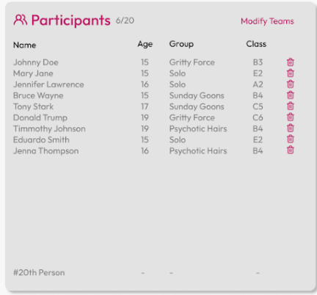

###### Code:

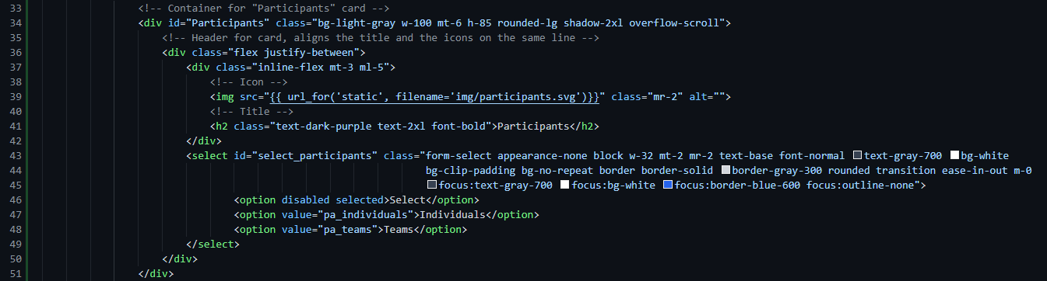

This snippet contains the icon, title and the select dropdown menu I mentioned previously. I have given the options a value of “pa_...” because I will have multiple select menus that relate to individuals and teams, so I have given them a prefix of “pa_” for participants in this scenario. The values also help to identify which option was selected, and allows me to display data based on what value is selected.

###### Output on Browser:

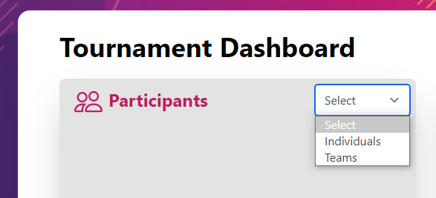

##### Participants table:

Before I begin the front-end for this section I need to carry out a lot of back-end code. This includes the creation of and linking to a database, as well as creating models that can be called to then insert data into the database.

###### Creating the Database and Database Models:

First of all, I need to create a file called “models.py” in the website directory. Then I need to import some flask modules that allow me to create these special database models, and then create said models. Evidencing of this is in the screenshot below.

I will be creating the database inside the “models.py” file, however I will import it into my “app.py” file and initialise it on start-up there. The reason I decided to do it like this is because if I define the database in “app.py”, I will get “circular import” errors which means I import 2 files to each other, so I will simply define the database in the models file, and import it into the app file, meaning models does not need to import app into the file. This will be a local “.db” file and I will use Flask_SQLAlchemy to allow me to interact with this database. The code on how to do this is below.

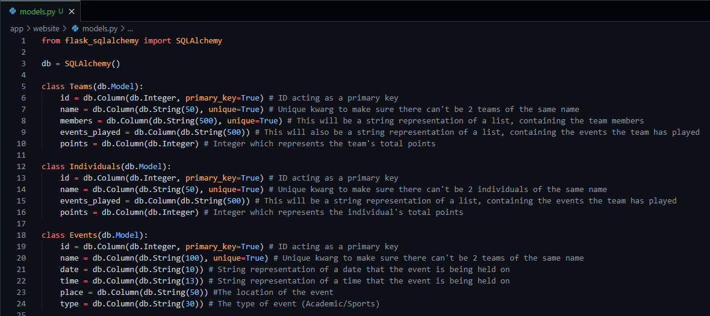

There will be more added to this file later on to help with the login feature.

###### Creating the database file and connecting to it:

In order to interact with the database, I need to initialise a connection with it, but database creation also needs to be automated with the models created in models.py due to the various data types and column constraints listed in the screenshot above.

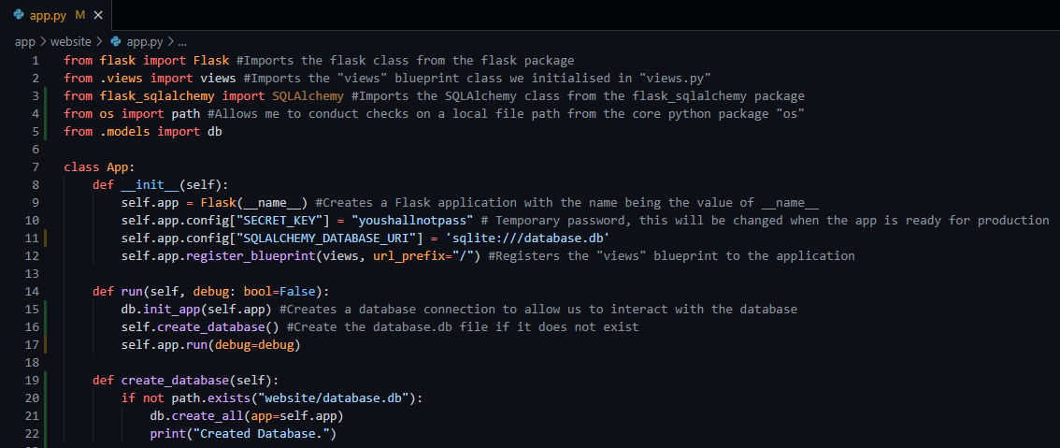

###### Adding data to the database:

The data that I’m about to add to the database is only for testing purposes, the database will be cleared when it is sent off to the client. There are also a few statements I need to write in order to add this test data to the database, I will write this code under the home function in the “views.py” file so that all I have to do is load the home page, and it will execute the statements I write.

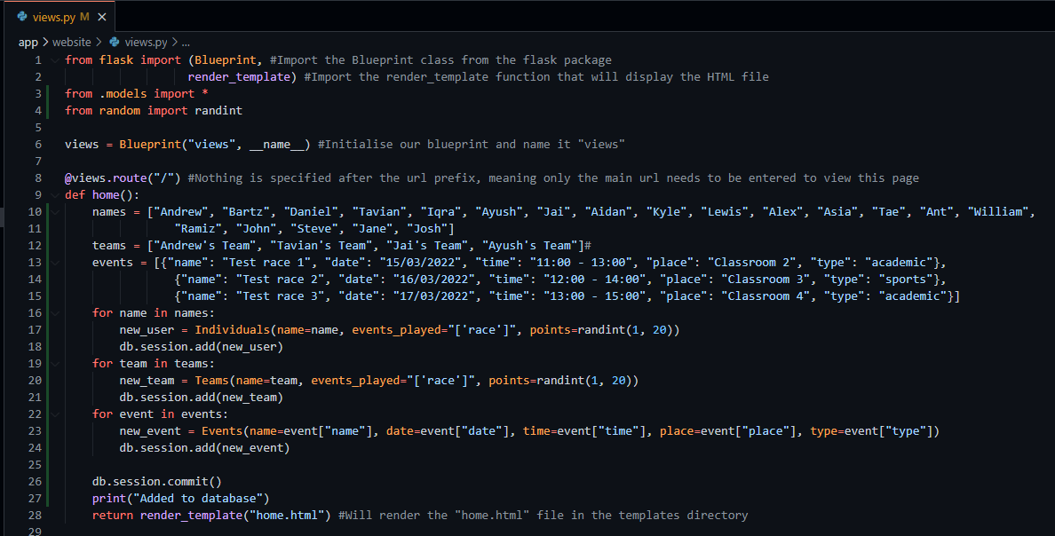

Here I have just defined 3 arrays (lists) containing data that I want to commit to different tables on the database. I simply loop through every item in the list and create a new instance of each of the models and then add it to the database. I randomly generate a number from 1 to 20 as a placeholder just so that each entry has a number of points defined. Giving each entry a different number helps to evaluate whether future sorting statements work when creating a leaderboard from the data.

After reloading the home page, the statements are run and as seen below, the data was entered to the database.

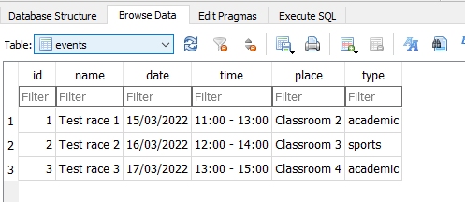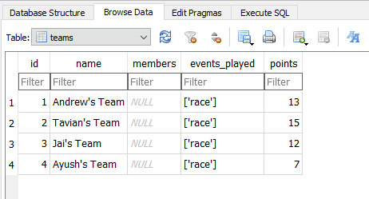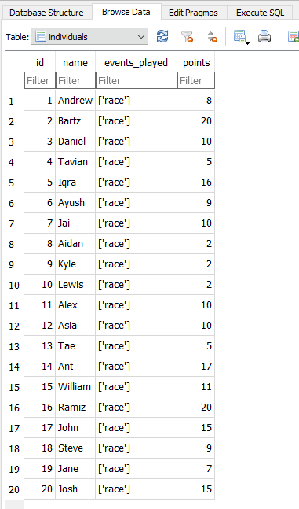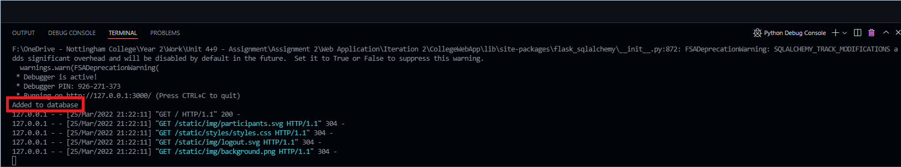

To allow me to view this data, I am using an application called “DB Browser for SQLite”, it allows me to open my database file and view the tables and the data they contain visually, rather than having to run SQL statements to fetch the data from the database to view it.

###### Handling the data and displaying it:

This section is the first instance of where I will be using python code (Possible by using Jinja2 with Flask) inside my HTML file. I will be using it to loop through the lists that contain the data from the database, and displaying it in a styled table in the participants tab. I will also have to add some JavaScript code to make the select menu element I implemented previously functional, and display data based on what option they choose.

First of all, I added a notice to the user to select an option so they don’t miss it, or in case they don’t know what to do:

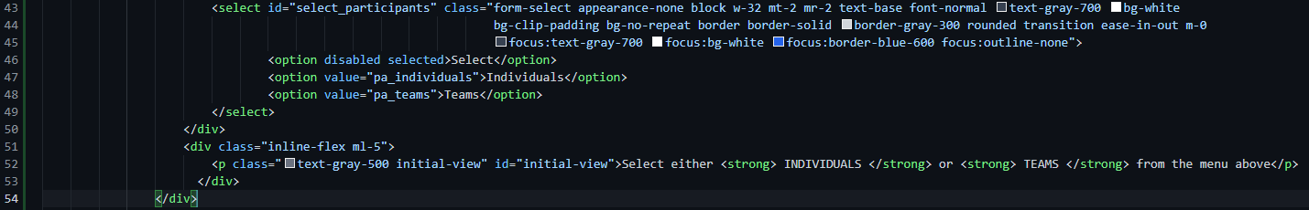

Next I need to actually fetch the data from the database inside of “views.py”, and feed it into the HTML file via a kwarg in the render_template function



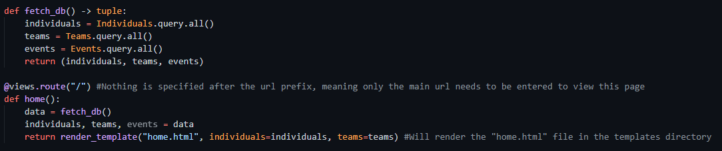

Here I create a function called “fetch_db” that will query the database and fetch every entry from the individuals, teams and events tables and returns a tuple containing this data. I chose to return it as a tuple so that the data cannot be edited, even by mistake, as the program continues. I pass the individuals and teams into the HTML file via a kwarg as I mentioned previously, and they can now be used and manipulated inside of the HTML file.

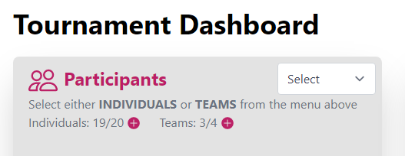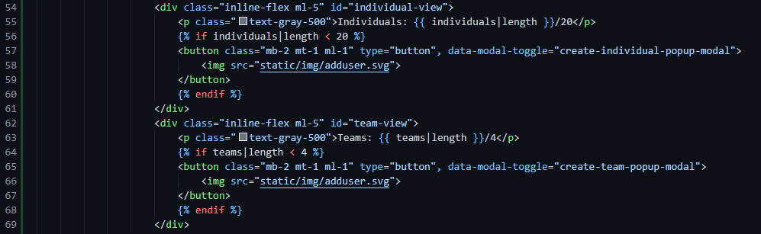Below is the first instance of me using python/Jinja2 inside my HTML file. What this snippet does is it takes both of the individual and teams lists I defined in the screenshot above, and I use “individual|length” or “teams|length” to display the total amount of individuals and teams entered into the tournament. I also added an extra, where it would only display a button to add a new individual or team as long as the total of individuals or teams is below their respective maximum entries (20 individuals, 4 teams). Finally, I have added the “data-modal-toggle” attributes to the buttons because that will be what links them to the modals I create later on in the application, that allow the user to add a new individual or team, and since they will display different modals, they have different IDs attached to them.

The 2 text elements displaying the totals won’t always be showing, I will add a JavaScript function later on alongside the table displaying all of the data to only display a certain text element based on the select option that is chosen from the menu above it. But for now, both elements will be showing.

Next up is the tables displaying all of the participants. Initially, 2 tables will be showing because I will have separate tables defined for the individuals and the teams, but I will be implementing some JavaScript that manipulates the relevant CSS classes to display or hide certain elements based on the selected option.

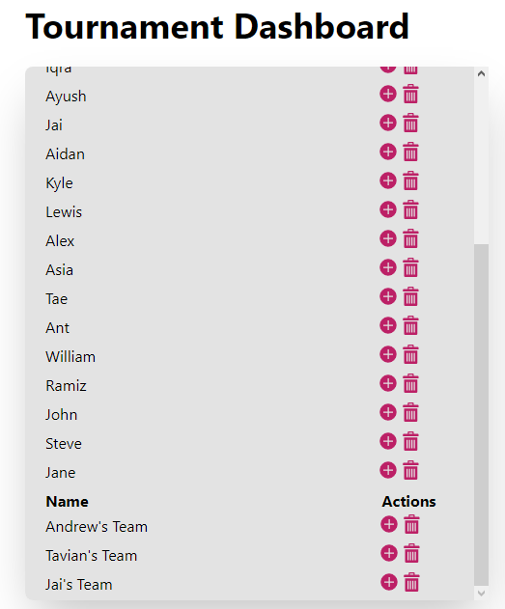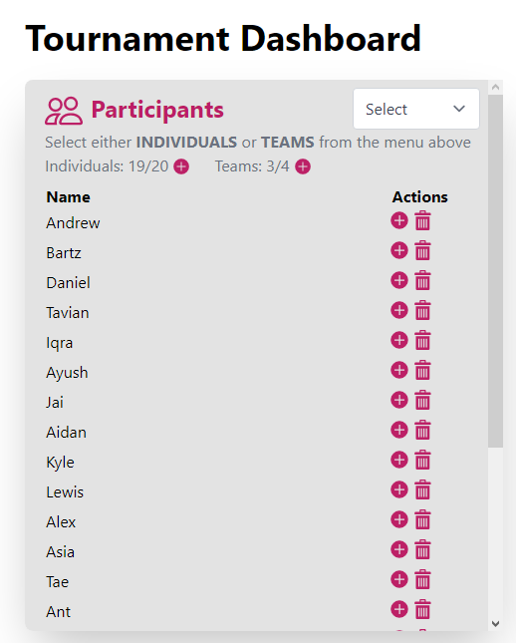

The screenshot above not only shows the overflow CSS class I created in action, but also that the data has been correctly fetched and imported from the database into the HTML file.

###### Graphical user interface, text, application Description automatically generatedHiding data on default and giving select menu functionality:

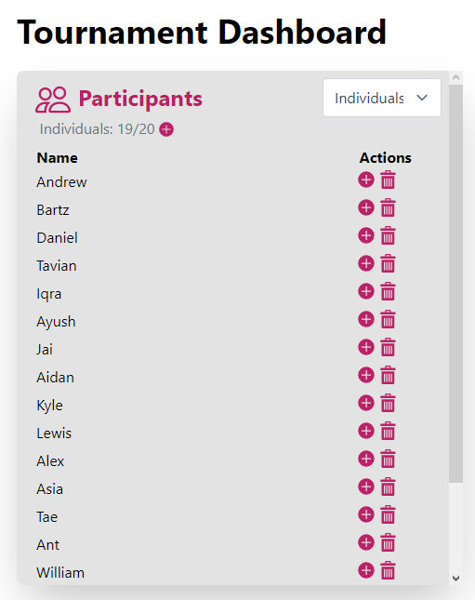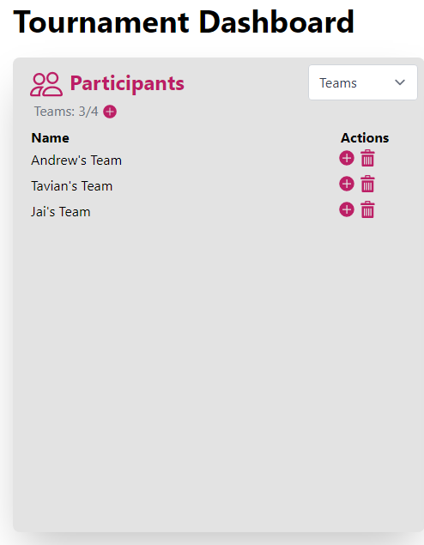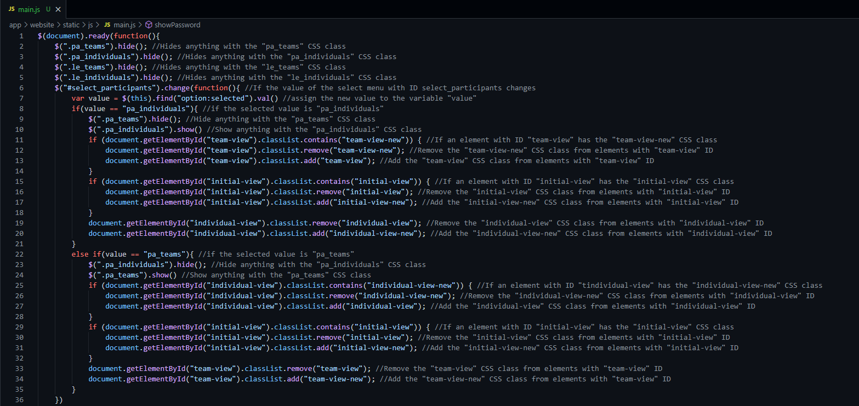

The screenshot above displays the JavaScript that controls what data is displayed based on the select menu value. However for this to be functional, I need to reference it in the HTML file, which imports the JavaScript in this new .js file located in the static/js directory. I also need to reference a jQuery CDN to allow for me to run jQuery (a JavaScript library) in my imported JavaScript.

The results of this can be seen on the right of the JavaScript screenshot. I have defaulted nothing to be displayed inside of this tab if nothing is selected, and the notice for the user that was previously there will be the only thing that is displayed, as seen in the screenshot below.

##### Leaderboard Tab:

###### Leaderboard Header:

The leaderboard header is going to be very similar to the participants header based on the select menu, and the notice accompanying it underneath. As seen with the designs, the tab is just simply going to be the header described above alongside a list of every player, their ranking and their points.

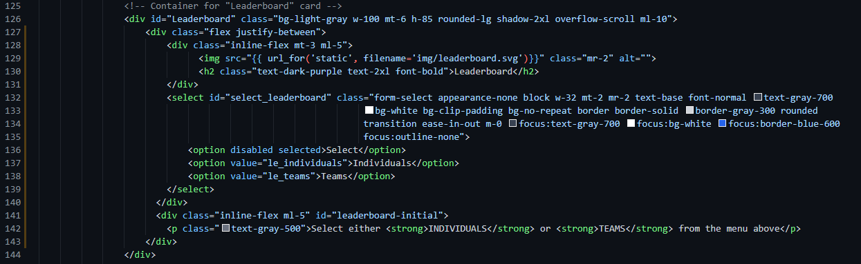

Since I already prepared the JavaScript for this select menu as well, I don’t need to do any further JavaScript to give this select menu any functionality, it is now already functional as I used the correct element ID and class name(s) where relevant. All I need to do from here is loop through both the “Individuals” and “Teams” lists and display them on the Leaderboard tab.

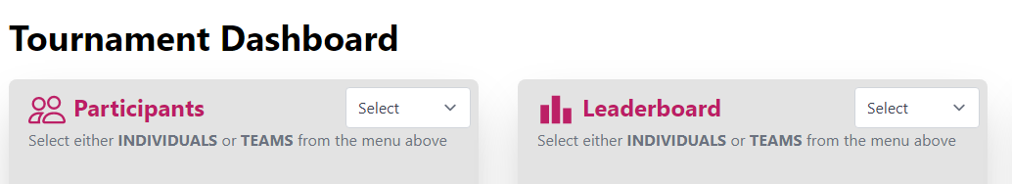

###### Displaying the data on the leaderboard:

Before I begin displaying the leaderboard, I need to format the data defined in “views.py” in such a way that orders the list in point order. Python has a core method built in called “sorted(list, key)” where you can enter a given list, and sort it in the order the key specifies. In this case, I used a lambda function to get the element’s point total, and order it using that. Since this key would order them in order of lowest to highest, I also had to add the reverse kwarg and assign it a True value as seen below.

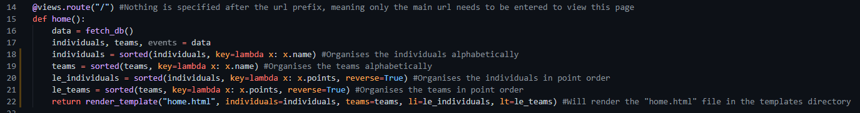

This now allows me to fetch the orsdered data in my HTML file, and display it in point order with ease.

Here is the first instance of me defining a variable with Jinja2, as well as iterating through a list using a “for loop”. Every new instance of code has been commented with a short explanation of what it does. This snippet contains the code for displaying the individuals leaderboard – which similar to participants will only display when the individuals leaderboard select option is chosen. A medal is also placed next to the top 3 players as shown below, and their text is displayed slightly bigger for added effect.

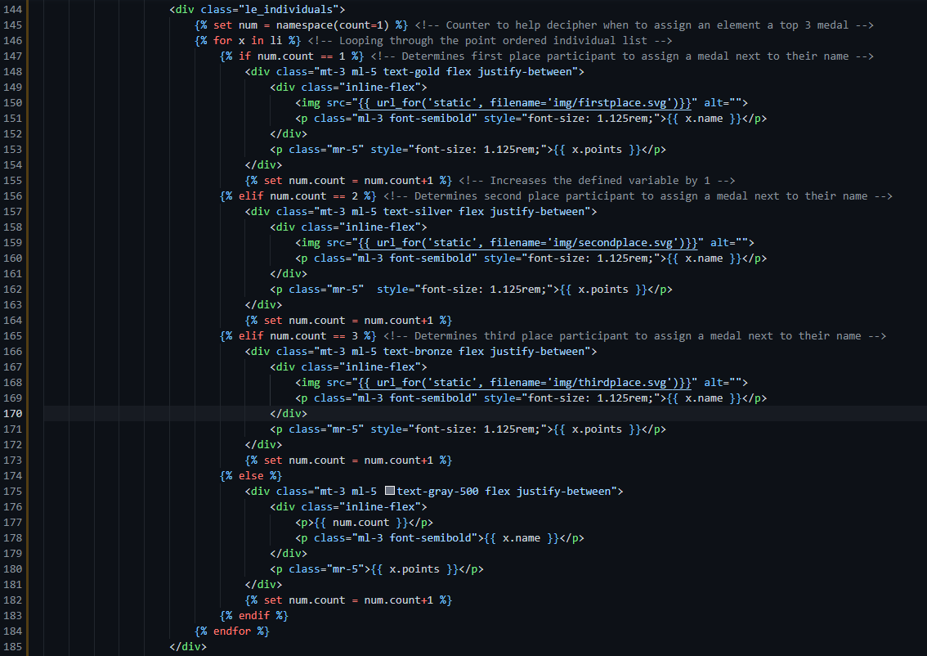

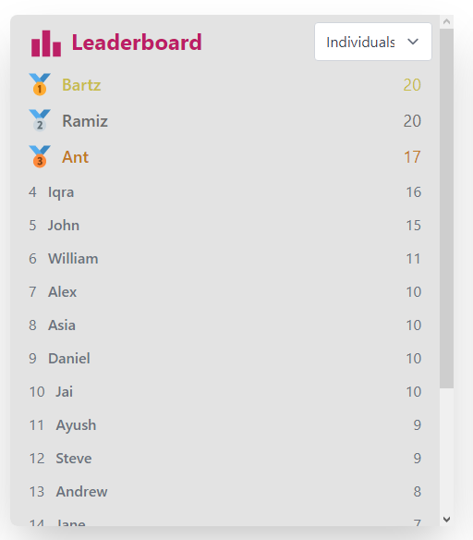

Next I need to do the same for displaying teams and their points and rankings. Since there can only be a maximum of 4 teams, the overflow scroll CSS class will be useless, since there is no way for it to reach the bottom of the div. As seen below, the code for displaying teams is exactly the same as for displaying individuals, except I am looping through the formatted teams list rather than the individuals list.

Note: I didn’t comment this iteration of the leaderboard, since it would just be exactly the same comments as I did for the individuals leaderboard.

Upon completion of this, it concludes the development of the leaderboard tab altogether, and will require no further revisions, based on the designs I have created.

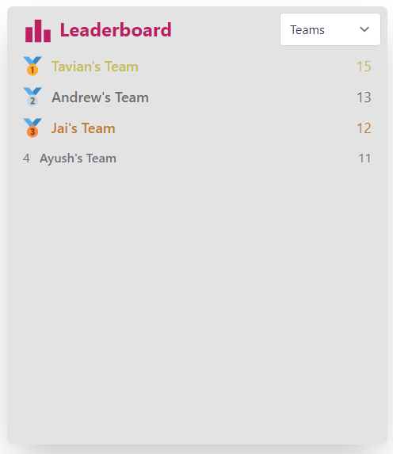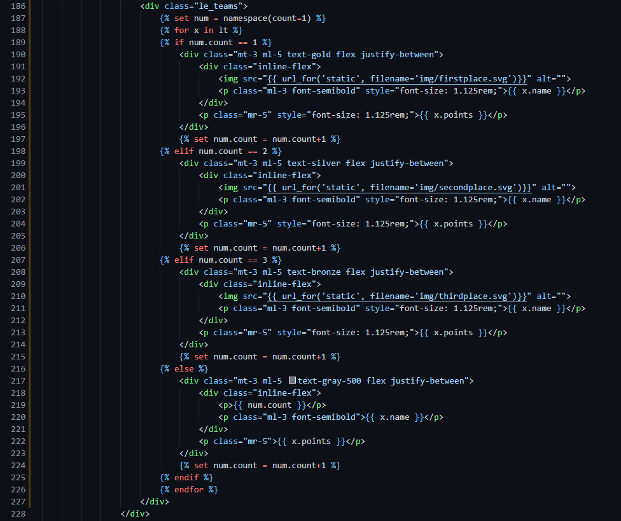

##### Events Tab:

###### Events Header:

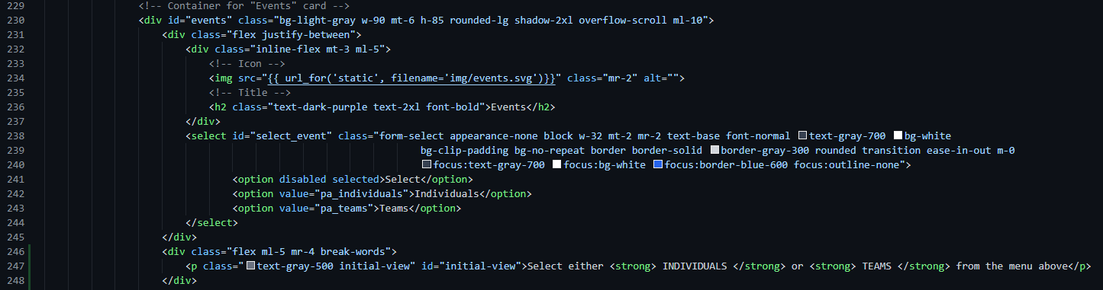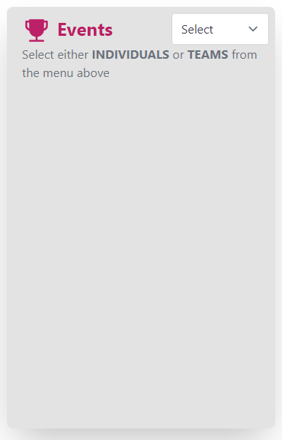Similarly to the previous 2 tabs, upon taking feedback before I will also be separating the events for teams and individuals, and again this will be done so via a select menu.

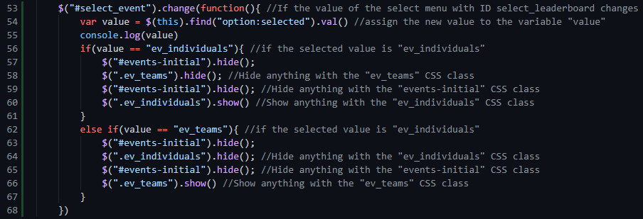

I also went ahead and created the JavaScript function for this new event select menu as well. Once again basically a replica from the 2 functions prior.

###### Displaying the Events:

Since there are already some events stored in the database, I don’t need to setup the add icon just yet, I’m going to focus on being able to actually display the data first. I will do this in a similar format to how the participants are displayed, except there will be 1 additional if statement that checks if the event is an academic event, or a sports event and split them into 2 tables – the same way individuals and teams were split into 2 tables.

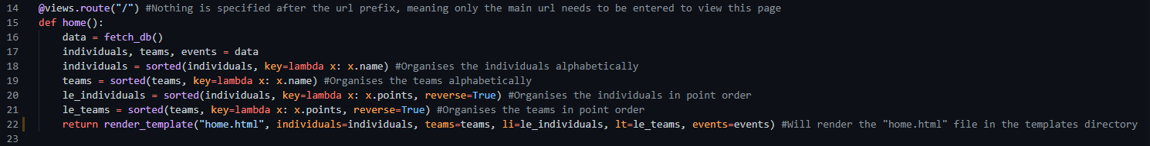

First of all I have to add an events kwarg to the render_template function so that all of the events fetched from the database can be passed through into the HTML file.

Up next I take the events list that I just passed into the HTML file, and loop through it, displaying every event that is stored on the database.

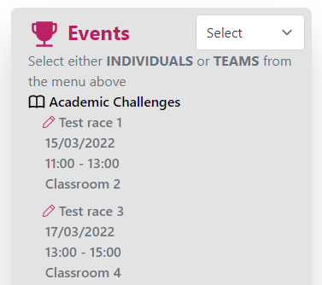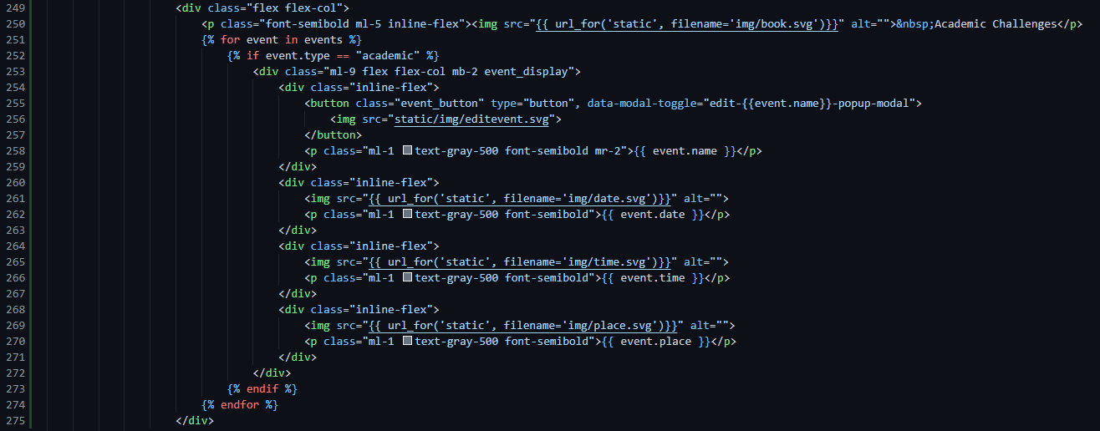

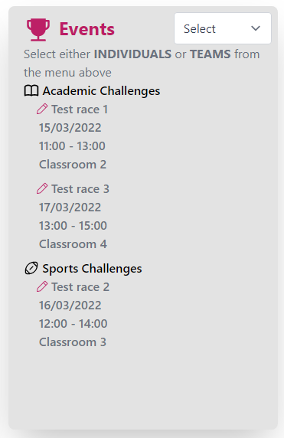In this snippet I am looping through the entire “events” list but I am only taking the ones that have a value of “academic” for their type. Next I will add a duplicate of the above snippet that instead checks if it is a “sports” event, and then display it underneath the academic events.

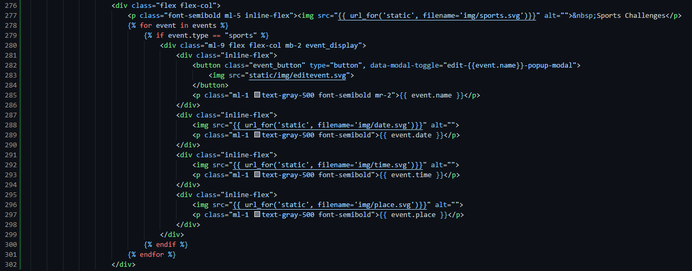

As you can see to the right, it perfectly displays the sports challenges directly underneath the academic challenges. You will also notice I have more data-modal-toggle parameters, this is for once displaying all of the data is complete, and I add compatibility for adding new participants, scores and events.

Now I need to add the relevant IDs and classes to the data being displayed, so that the select menu accompanying it has some functionality. In order to properly account for whether it’s for individuals or teams in the database table as well, I will be changing the format of the string stored in the database from just “academic” or “sports” to “team_sports” or “individual_academic” for example.

 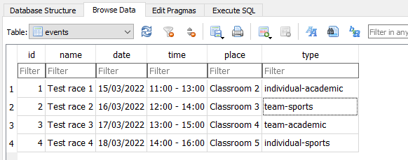

One last thing I need to account for is adding an extra few if statements to detect if it’s a team or individual event, on top of whether it is either an academic or sports event.

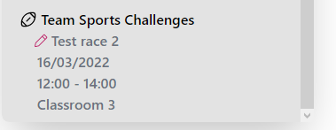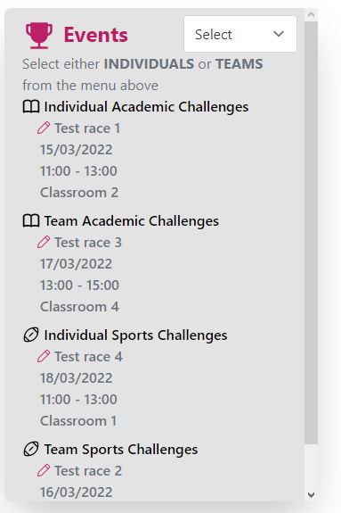The screenshots above display the new event types that the application recognises. This allows me to separate each event type into a separate table, and display each one according to what option is selected in the select menu.

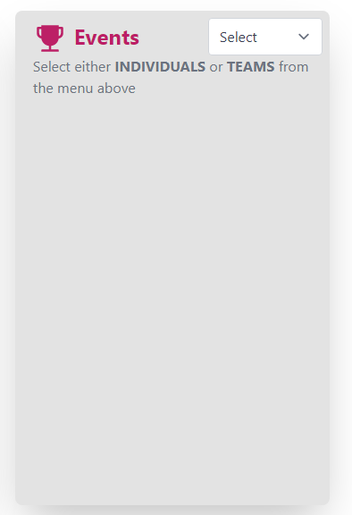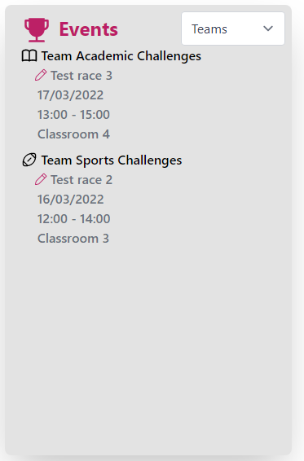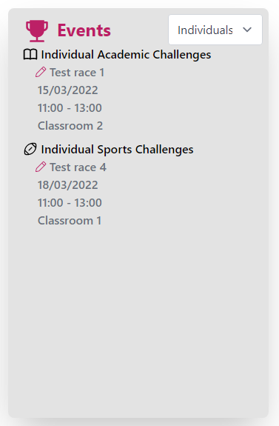This now correctly separates every event type, as well as if it’s an individual or team event. All that’s left to do is to add CSS classes and IDs that the JavaScript function recognises, to allow me to display only what is selected. In order to do that I have added the “#select_event” ID to the select menu so that the menu is now matched with the JavaScript function, and will detect any value updates from it. I have also added the corresponding CSS classes to the tables (“ev_individuals” and “ev_teams”) so that the individual events and team events are now displayed separately based on select menu choice.

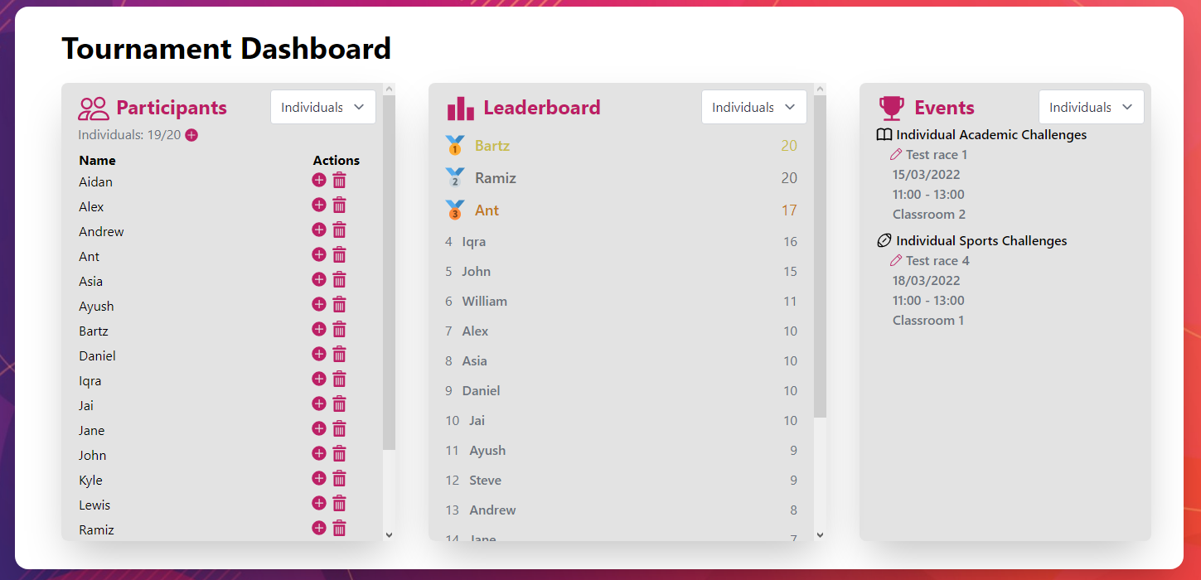

To allow for adding events, I have added 2 buttons, 1 for creating an event for individuals, and another for creating events for teams. Similar to displaying the events, the button only displays, for the corresponding event type (Individual/Team), and if neither is selected, no button is displayed.

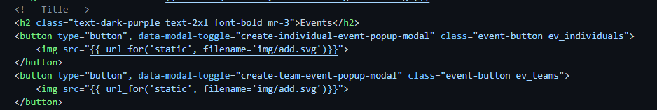

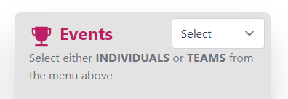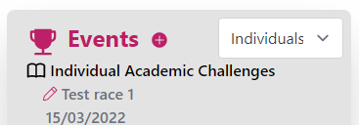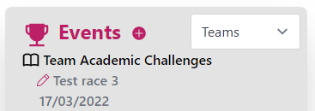

When it comes to displaying data, the application is complete. All that is now left to do for this page in particular, is add the functionality to allow for adding, editing and removing participants. This will be done through the use of popup modals that appear on the click of the icons that can be seen in the code screenshot above.

##### Add Individual Participant:

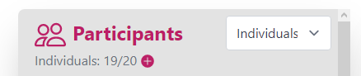The way to add an individual participant is by clicking the + icon that displays after selecting “individuals” from the select menu in the participants tab, as seen on the right.

The way I plan to implement the ability to add a new individual participant is by displaying what’s called a “modal” to the user, that displays a singular text field that asks for this person’s name, since no other player data would be required at that stage. Note – based off the initial feedback I was given, I have also decided to keep everything minimalistic and on one page. When I was informed I was displaying too much data, I also realised I was simply using that unneeded data to fill up space, so rather than spreading it across multiple pages, I will use modal pop-ups to get data from the user, rather than separate pages.

###### Creating the modal:

Before creating this modal, I need to import a new script via a CDN (Content Delivery Network) link. 

The modals are linked to buttons simply by assigning the modal I want to be displayed an ID where its value is equal to the data-modal-toggle tag that we apply to the button. For example where the add individual button has this:



The modal I want to display will have the following inside its main parent div:

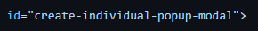

The following snippet displays the entire code needed to display a modal:

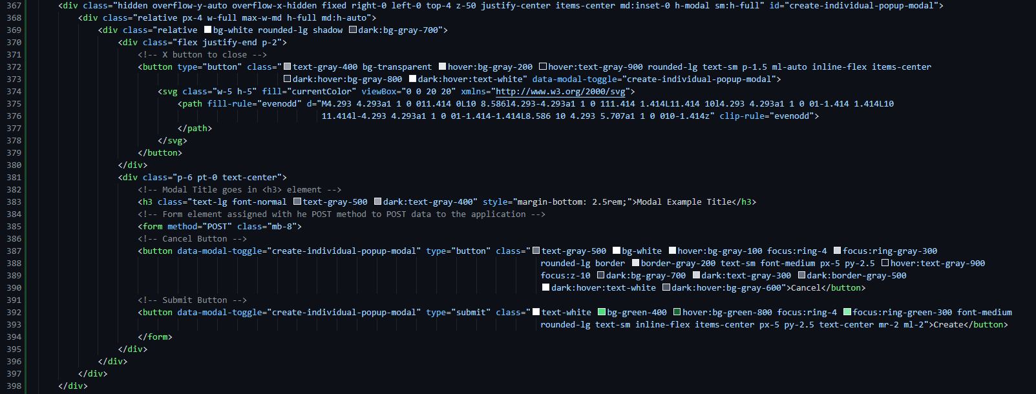

Since displaying the modal also dims everything behind it slightly, I have shown the entire screen for this screenshot. This is an extremely basic example of the modal “template” I have created for this application in particular. Every modal will use a form of sorts and will have the “X” exit button as well as the “cancel” and “Submit/Create” button.

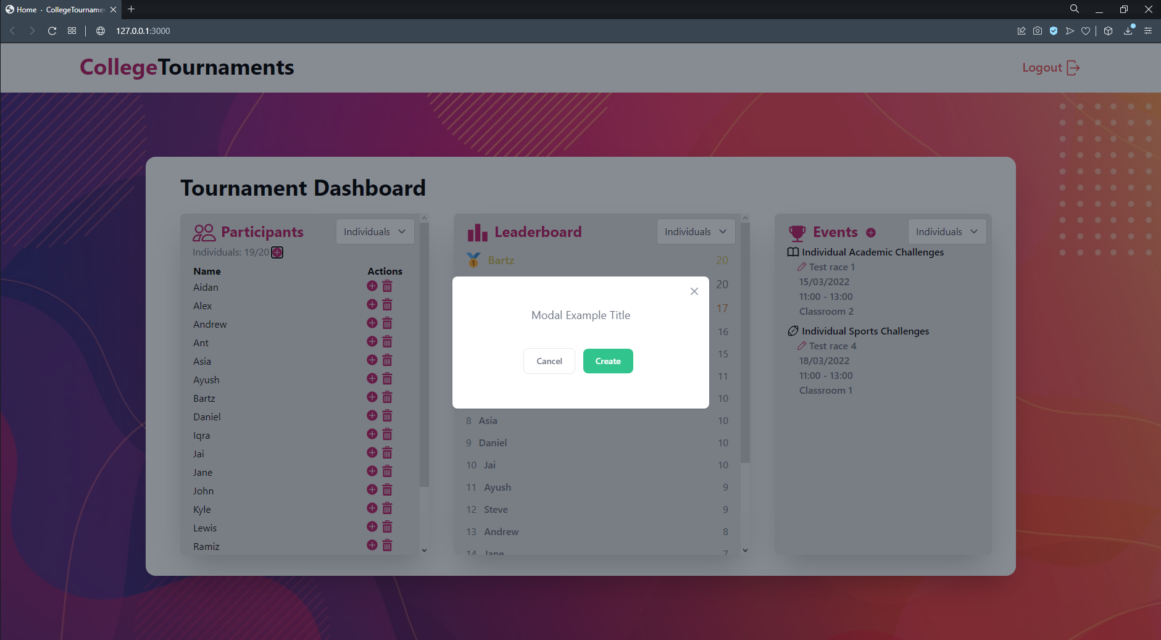

Once the relevant form, input box and title has been added to the modal, the code and output now looks like this:

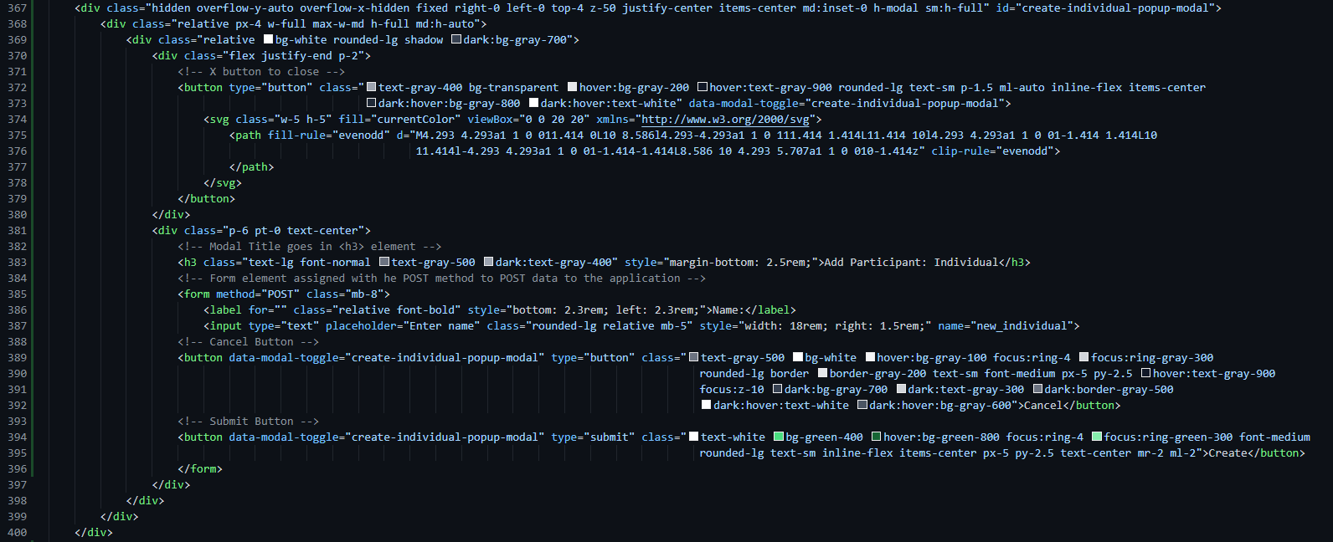

In the input element, I have added the “name” tag so that when submitting the form and converting the data POSTed into a dictionary format, I can easily identify the correct data, and it is also very helpful for testing, so that when I’m viewing logs in the terminal of a POST request, I can see if the data was actually sent through or not. Assigning a type of “submit” to the submit button rather than just having it as a regular “button” type is what tells the application to POST the data.

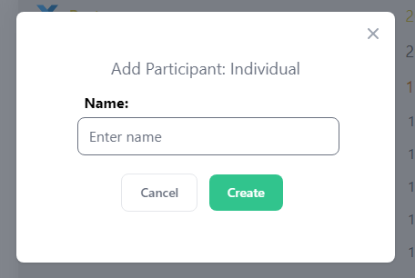

##### Add Team Participant:

For adding a team to the tournament, it will be exactly the same as above, except the user will be required to enter 5 names for the members of the team. This is to ensure a full team is being entered, a list of members won’t be displayed on the participants list, only the team name and the accompanying action buttons.

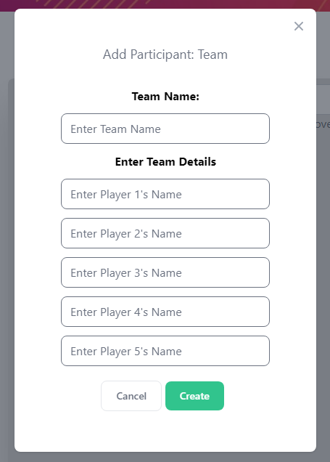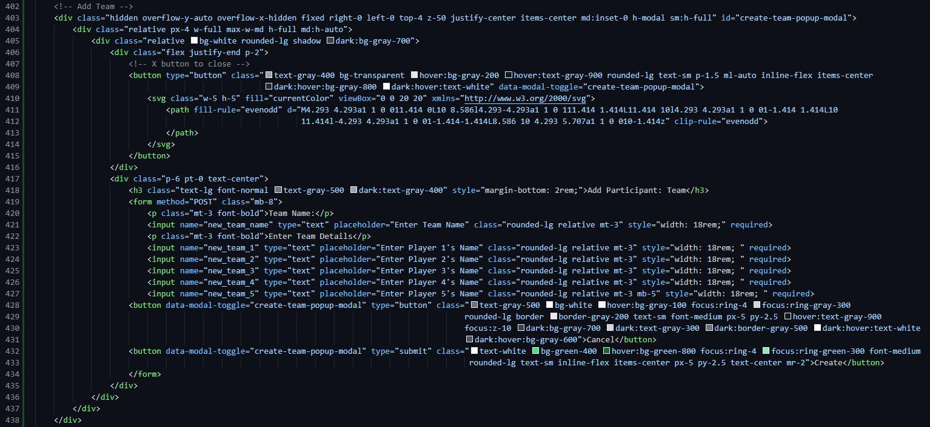The screenshot below displays the code to add a new team to the tournament. The only difference between this and the add-individual modal is that there is a text entry for the team name, followed by 5 entries for the player names. As mentioned before this is to make sure that a full team of 5 is actually being entered as specified in the client requirements. Finally, I have added the “required” tag to the input elements to make sure the user enters them, and is not able to enter half a team.

##### Add Individual’s event record:

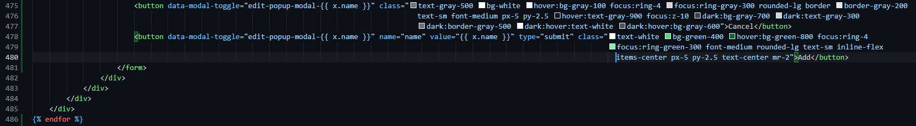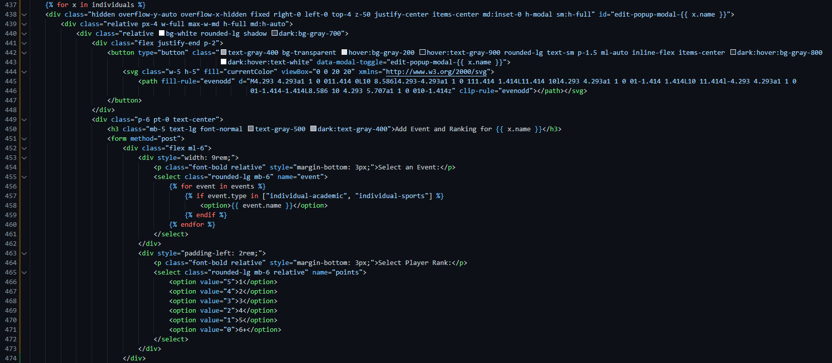The button for this action is the + icon located inline with the player’s name (screenshot below). The functionality for this action in particular will be unique due to it using data from existing events, to create new data. What is meant by that is there will be 2 select menus displayed to the user, 1 that contains every event registered on the database that is relevant to the player type (individual/team) and 1 that contains rankings for what position the chosen player came in the event. For individuals this will be 1-5 and then 6+ as I have decided to only award points to the top 5 players, meaning it is pointless to list rankings 6-20 since they all provide the same value. 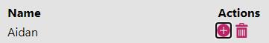

The above screenshot is how the edit participants screen (seen below) is coded. Just like the rest of the modals it is initialised with a header, X icon and submit buttons, but in this modal in particular it utilises 2 select menus, 1 of which listing every individual type event (as seen in the for loop where I check if the event type is either “individual-academic or individual-sports) for the user to select from, and the 2nd menu allowing the user to choose from a ranking between 1-5 or 6+. The point system I have gone for is 5 points for 1st place, 4points for 2nd place, 3 points for 3rd place and so on, and 0 points for 6th place and above.

One edit made to the pre-existing code from earlier development to note is that I have changed the data-modal-toggle ID to initiate this edit modal to be based on the individual object’s name, rather than looping and incrimenting the number every time, I have simply set it to be the object’s name, this could also work with the objects’s ID. This edit will be the same for the team’s edit modal.

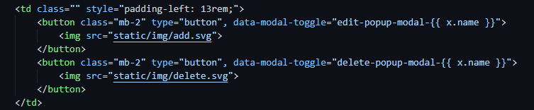

##### Delete Individual Button:

This button’s functionality is extremely simple. The modal that will be displayed is 2 buttons and a confirmation message since nothing more is needed for a delete button. This can also be implemented in the loop that the edit modal is initiated in, this saves me looping through the list of Individuals objects twice.

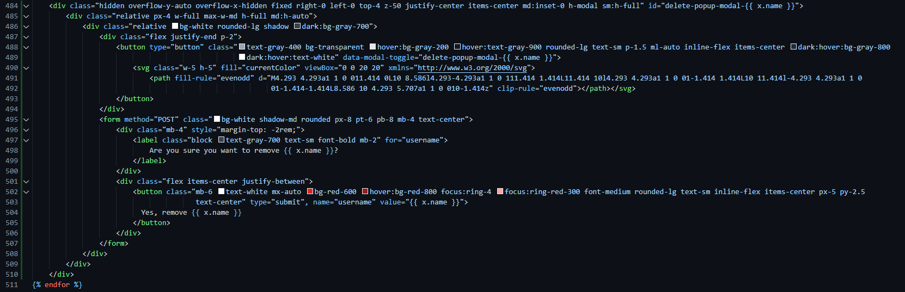

Here, there is no form input boxes, just 2 buttons where the user can either choose to cancel the deletion, or confirm it which sends a POST request and we will use the data posted to delete the entry via their username. This is a viable option, even as much as the Individual’s ID because the names are defaulted to be unique in the database, there can be no duplicate instances of the same name. If 2 individuals do share the same name, entering full name’s or adding an initial is always an option too.

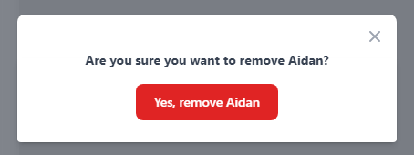

Popup that appears when you click the delete icon.

##### Add team’s event record:

This section will essentially be identical to the individuals section of this tab, the only difference will be that the modal will display the team-only events and display rankings 1-4, and give them points based off their ranking once again. 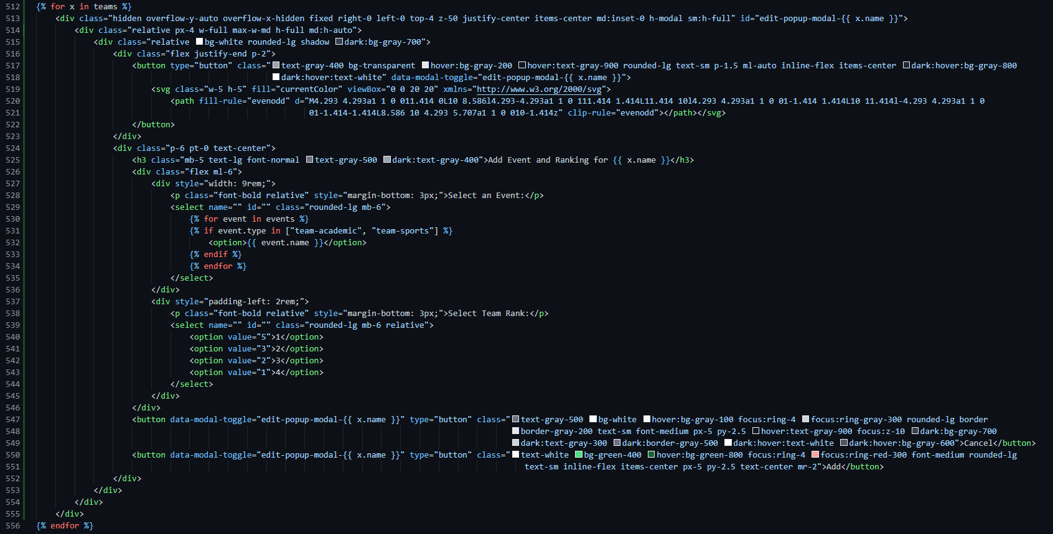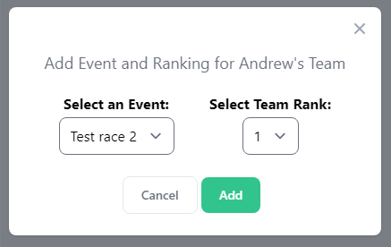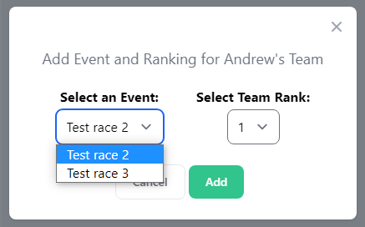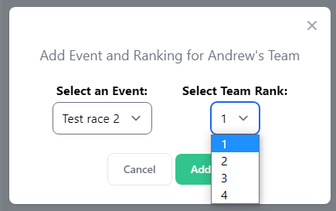

For teams, you are guaranteed to get points no matter what ranking you achieve, and the range of points will remain the same so that there is some kind of consistency between the individuals and teams, especially because this will be taking place in the same tournament. As seen in the screenshots, only the events for teams are being displayed, and only 1-4 shows since there can only be a maximum of 4 teams.

##### Delete Team Button:

This button will be identical to the “delete individual” button except it will delete the corresponding team rather than an individual. Again, because the name of the team has to be unique and cannot occur twice in the database, finding the database entry by team name is a viable option since it will only appear once, if it is there at all.

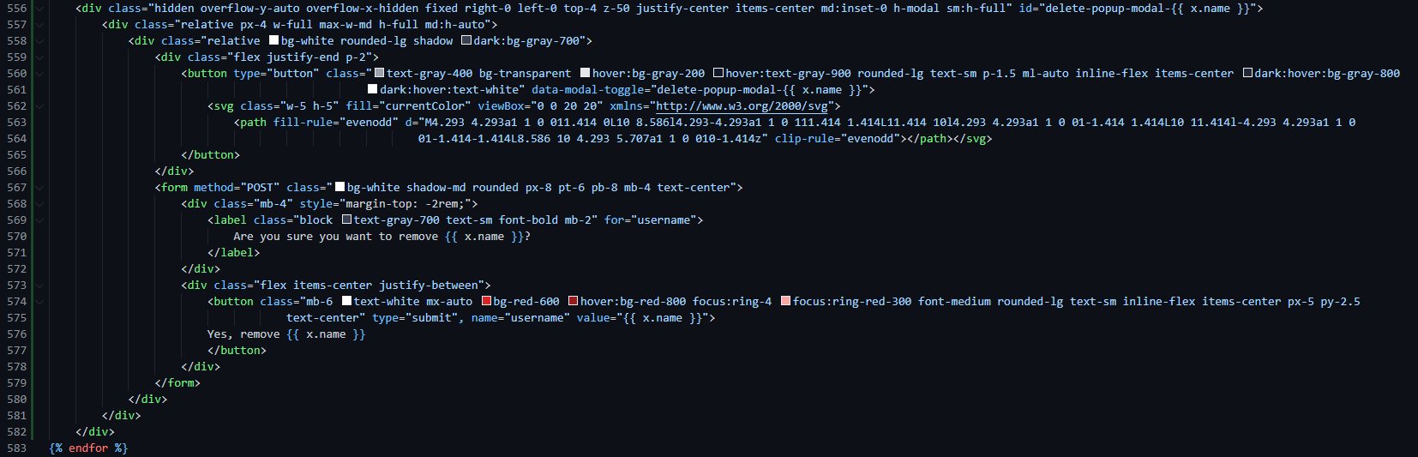

Popup that appears when you click on the delete icon next to a team.

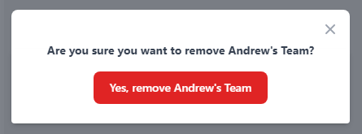

##### Graphical user interface, text Description automatically generatedAdd individual events button:

Since the add events button is pre-defined to show a button with a specific ID for either individuals or teams, we can use that to pass in the value for the POST request without having to get the user to specify that it’s a team or individual event. The details that are going to be needed from the user however are the following:

* Event name
* Event Date
* Event Time (start time – finish time)
* Location of Event
* Type of Event (Academic/Sports)

This will be achievable in a similar manner to how the team creation was completed, by a series of input boxes with short but specific enough placeholders.

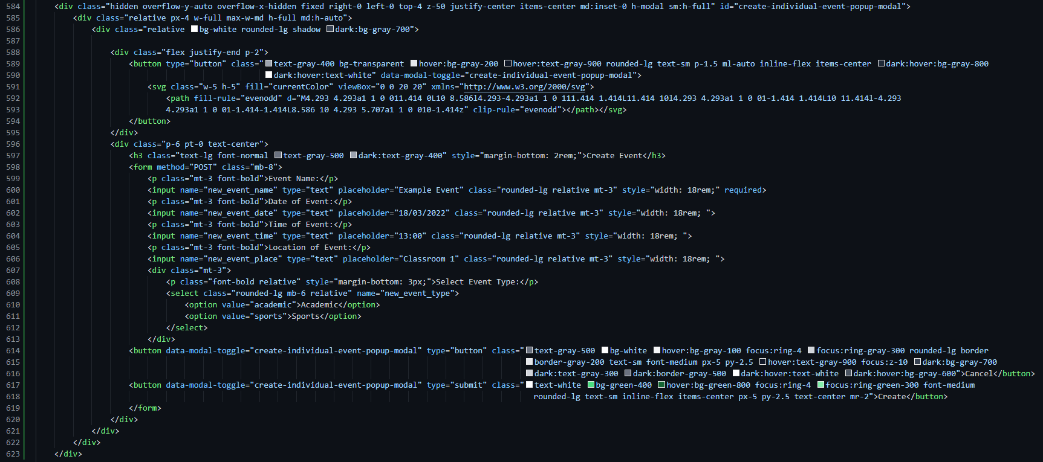The screenshot on the right shows an example of what the newly created “create event” modal displays, placeholders have been added to help guide the user on the format they should enter the data in, and there’s also a select menu that the user can pick from that minimalises input error from the user.

The code to the left is all that is required to display the modal for creating an event.

##### Add Team events button:

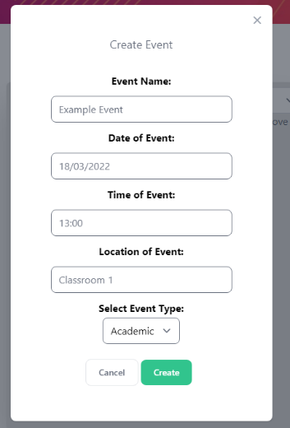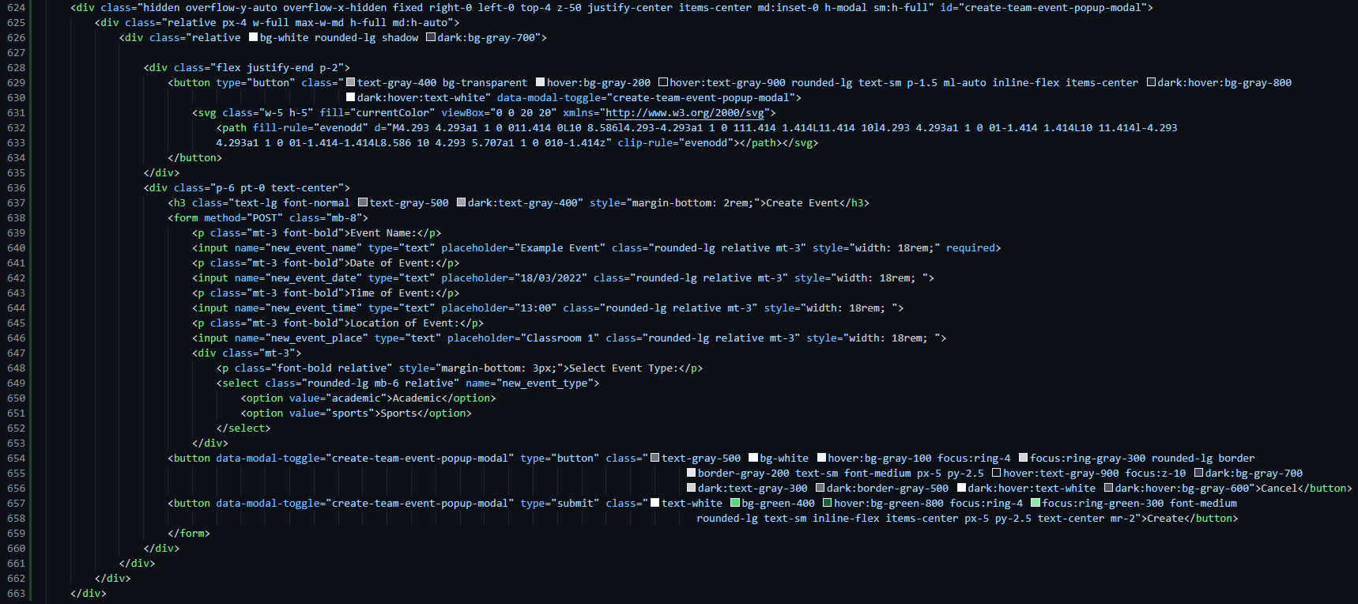For the team events button, it will be identical to the individual events button except the IDs will be slightly different, just so that the back-end of the application can detect whether it is being POSTed as a individual or teams event.

##### Editing Event Information:

For ease of access for the user, I have made it so that whenever the user clicks on the edit symbol for an event, it will automatically insert the existing data into the text boxes, so the user can view the data whilst editing it with ease.

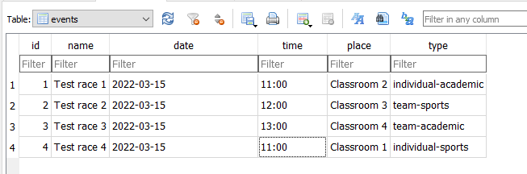

This function is found in “app.py” under the App class. All I need to do now is add |format_string_date to the end of a date and it will format it for me automatically

In order to have the data be automatically inserted into the database, I need it to be stored in a certain format. This specific format as seen on the left is not how dates are typically read, so I have added a custom template filter that will handle that for me.

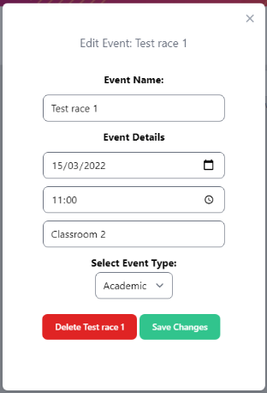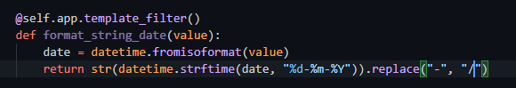  
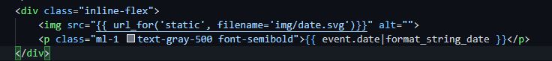

The date is now formatted to dd/mm/yyyy rather than yyyy-mm-dd. And is readable by the input box to allow me to auto-insert it inside. 1 last extra detail I have added is auto selecting the event type that the event belongs to in the dropdown menu at the bottom.

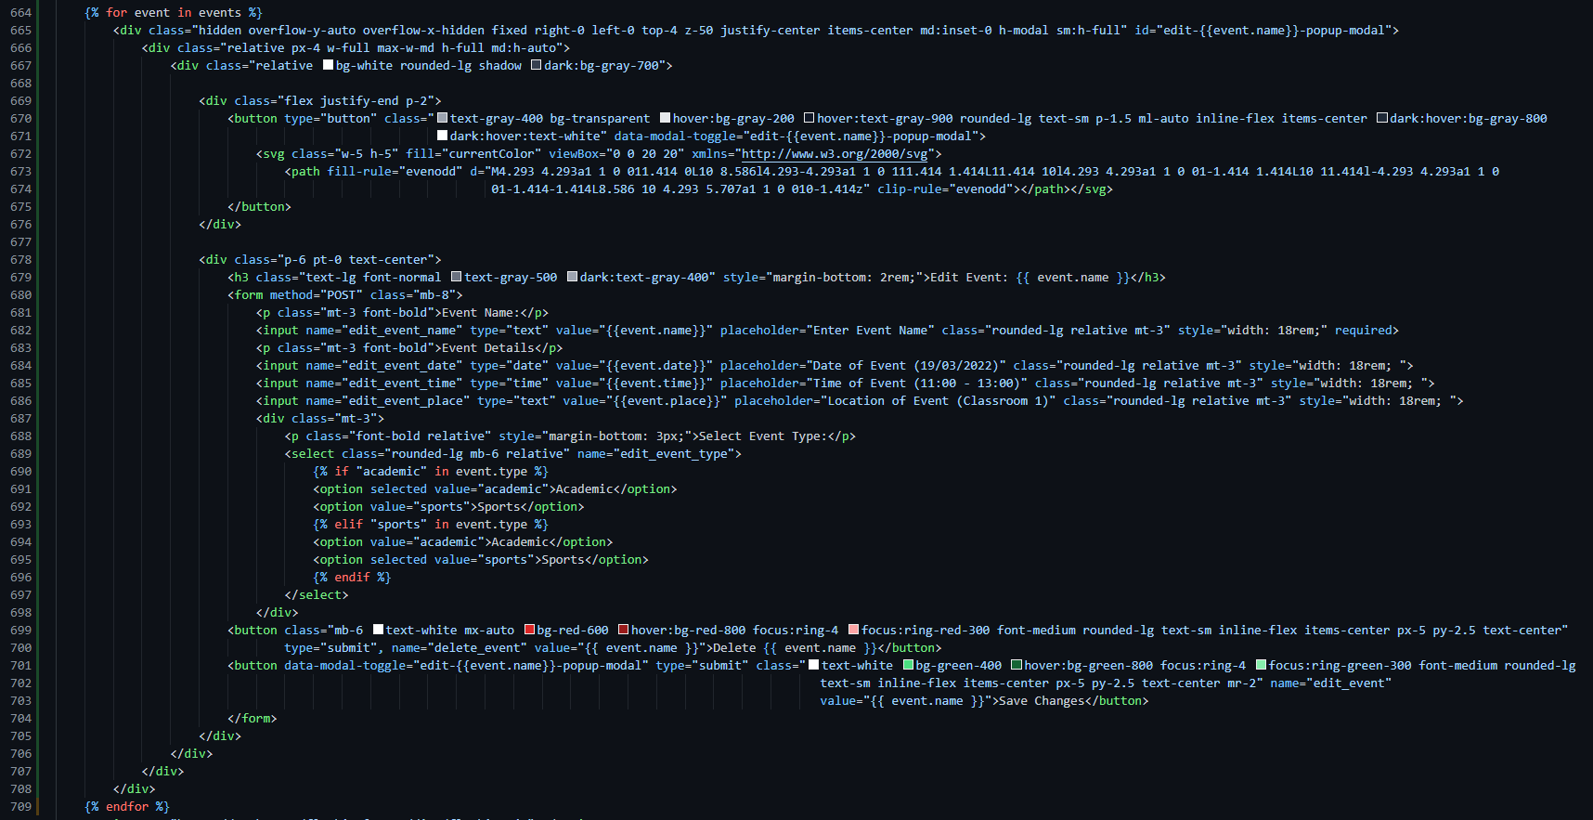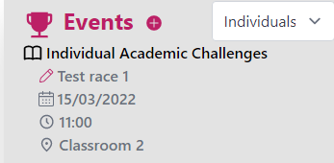

In order to keep the interface clean and compact, I have added the delete button to the edit menu as well, since adding multiple icons in that short space would take unnecessary space.

## Building the Login Page:

This is the current design for the login page, and upon multiple personal-reviews of the design I have decided that this is most definitely going to be the final design, with no design revisions whatsoever. It’s as simple as getting the CSS right to perfect the layout, a little JavaScript behind the view password button and a form to submit the login information. But before I get onto any of this I need to create a new model in models.py for User logins.

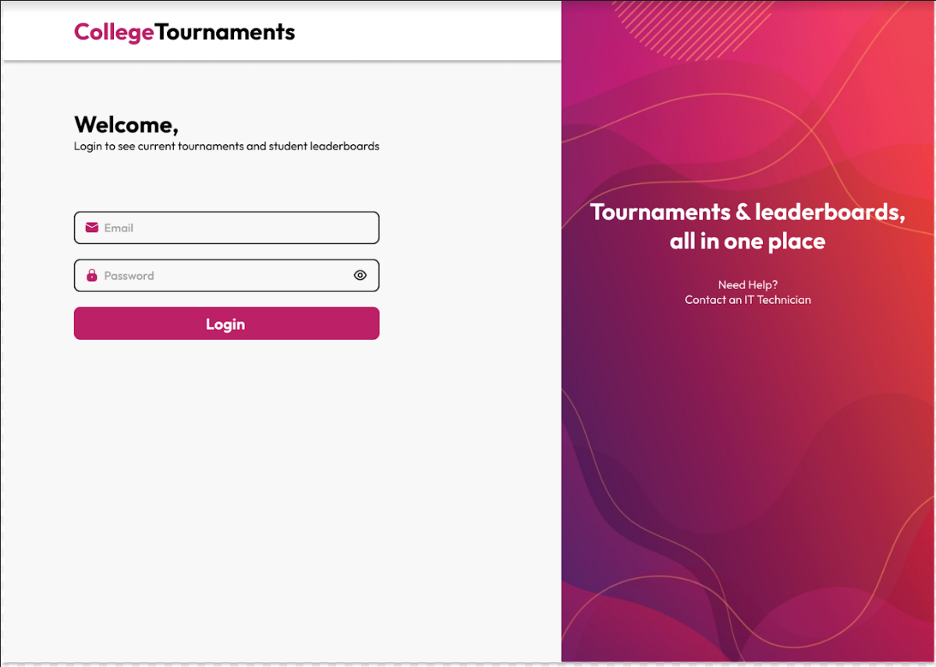



I have created a new “view” inside of views.py for the login page. The “methods=[…]” is where I define what methods are allowed to be used on this page. POST will detect when the user submits a login request, and GET is simply loading the page or fetching information.

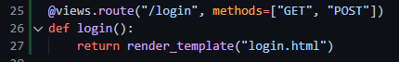

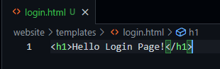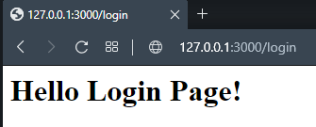

The test to see that the HTML page is connected to the view is complete and everything appears to be functional. Now I just need to import the correct stylesheets and JavaScript files and the login page is ready to be created.

### Preparing the head tags:

Here I have imported my CSS and JS files, and the login page is now ready to be created.

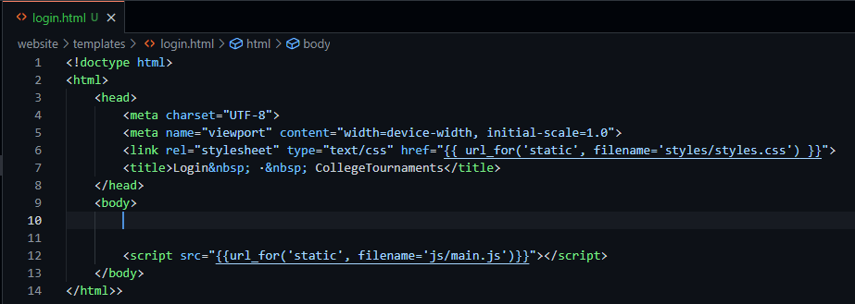

### Creating the navigation bar:

For the login page, since there is no need for the logout button since we’re logging in, there will be no items on the navigation bar other than the title, so it’s more fitting to call it a header this time around.

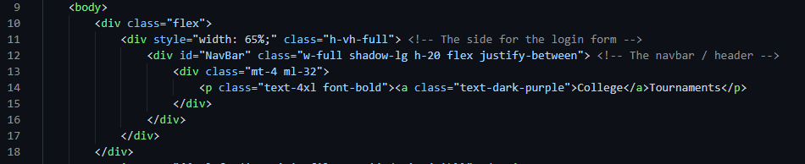

This snippet here creates the header/navbar, and because its parent class ends 65% of the way to the side of the page, so does the navbar. This is to allow for the placement of the side-image which comes next.

### Adding the side image + text

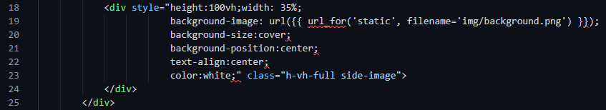

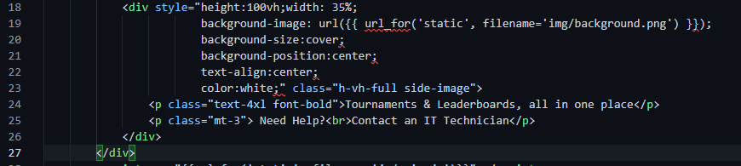This piece of code is all that is needed to be able to display the side-image on the page like this:

Next all I need to do to complete the right side is to add the help text displayed in the initial designs that I created.

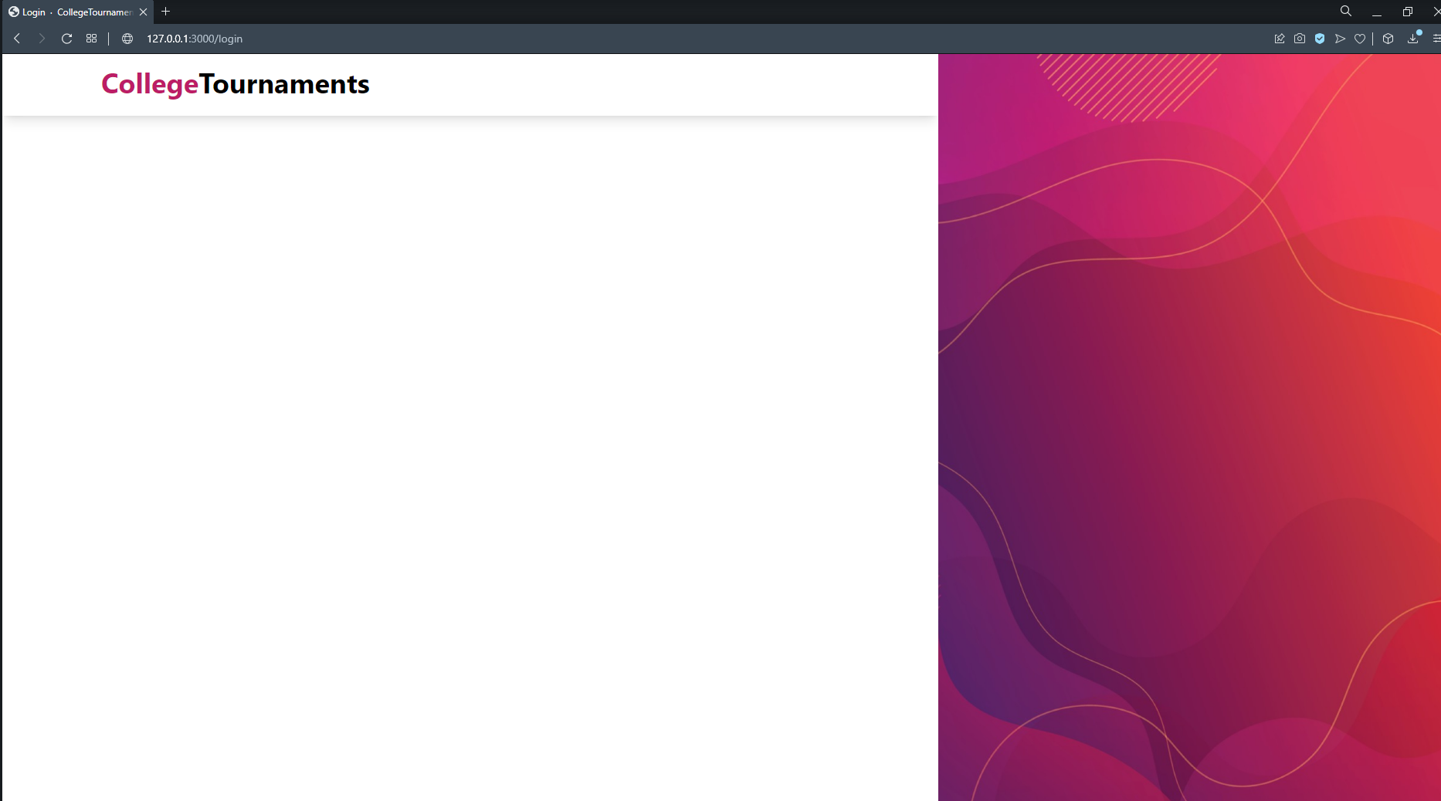

The CSS classes, and styling set for this element is what allows the text to be positioned perfectly centred as shown to the right:

### Adding the login form, and other text on the left:

The welcome text in the top left is displayed by doing the following:

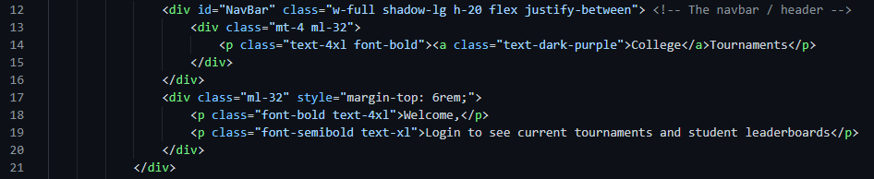



### Adding the login form:

Finally, all that is left in terms of front-end for the login page is just adding the login form. This is shown in the screenshot below:

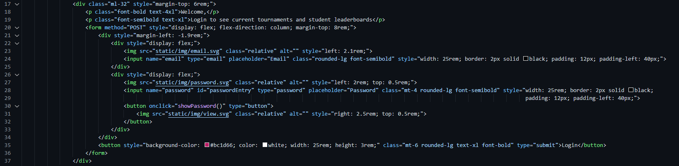

The above code gives the following results:

Finally, I just need to create the JavaScript function called showPassword() to give the eye icon functionality to allow the user to view their password whilst entering it. This simply changes it from a password input box to a regular text input box, and vice versa.

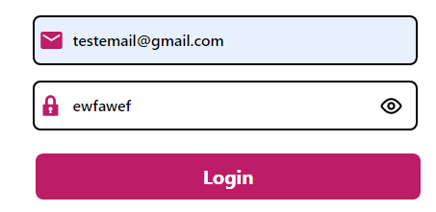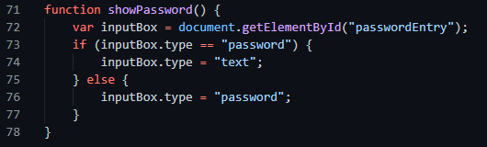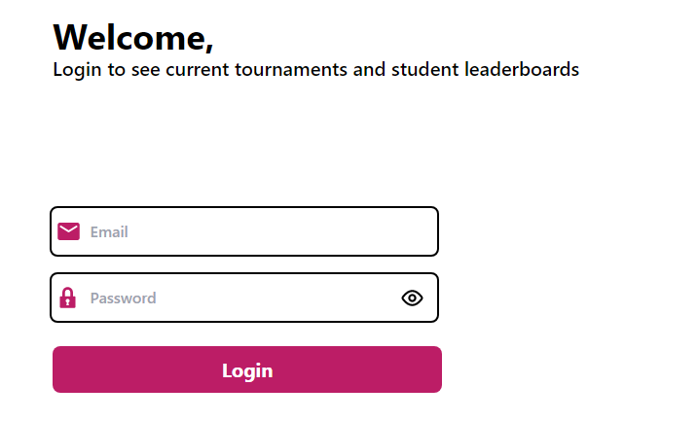

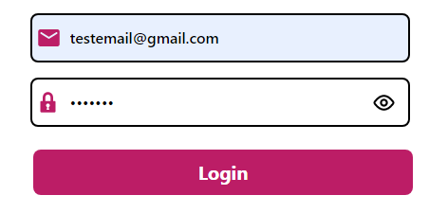

## Handling POST requests:

### Adding a new participant:

Handling POST requests is actually made to be quite simple with Flask. You simply import “request” from the flask package and I can use it inside my functions after checking if a POST request was made. 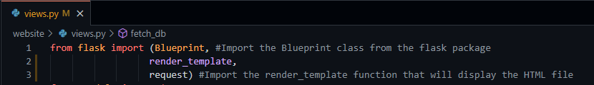



Here I simply check if a POST request was made, and if there was one made, it will print the data of the request as a dictionary in the terminal. I can test if this works by trying to add a new individual on my home page.

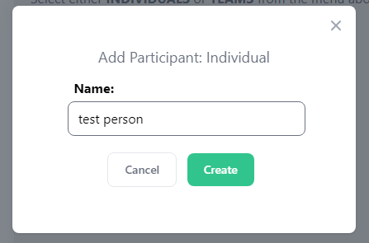

Here I’m going to be importing an exception from a security package called “werkzeug” that allows me to easily detect if an element exists in a request form or not

As soon as I pressed “create”, this appeared in the terminal, which shows that the application successfully retrieved the correct data, and is now in such a format that allows me to easily handle it and interact with the database.

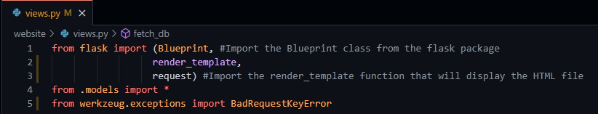

This small chunk here is the “template” of how I’m going to handle every request we need to for the home page.

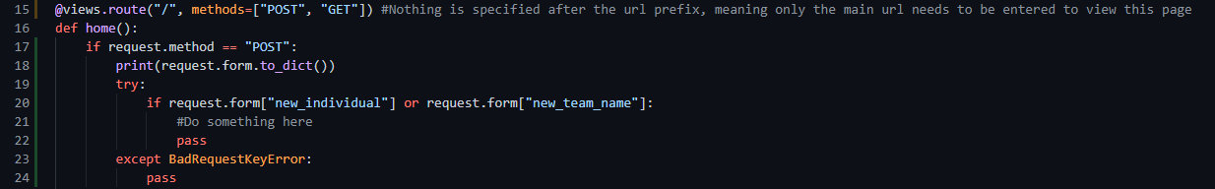

The try and except statement above simply checks if a certain key exists in the request form, if it doesn’t, naturally the program with raise an error called “BadRequsetKeyError”, but if I catch that error with a try and except statement, it won’t crash the application, and it will in fact then go on to check for further keys that I later specify in the program.

I will be making dedicated functions for handling every type of request I want the application to do, for consistency and cleanliness of code purposes.

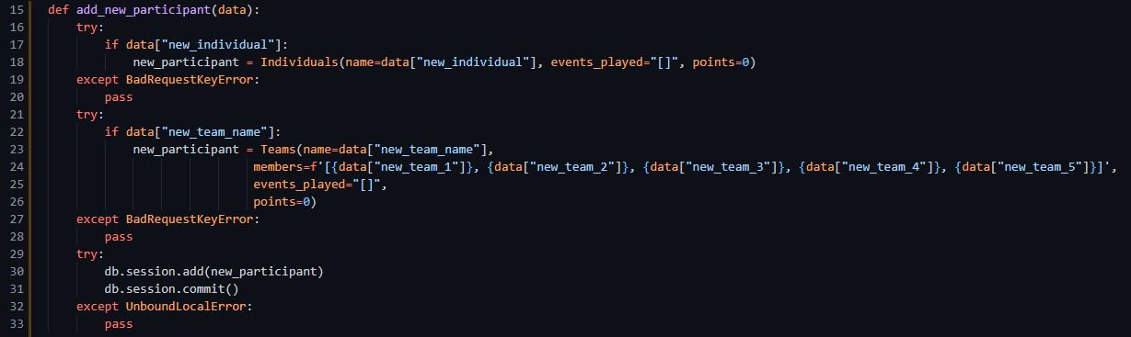

This function is for adding new participants to the database. It is passed a data argument that contains a dictionary with every item in the request form. It then checks to see if it either has a key for “new_individual” or “new_team_name” to help decided if it needs to create a new individual object or a new team object, and will then add it to the database, and commit it to save changes. The “UnboudLocalError” exception is essentially checking for if the variable “new_participant” does not exist and if it doesn’t, just end the function and do nothing since no relevant data has been passed through.

Before I use this function and handle the data I receive and commit to the database, I need to ensure that what happens after this function is complete is also accounted for. Before that happens I need to import some more functions from the flask package:

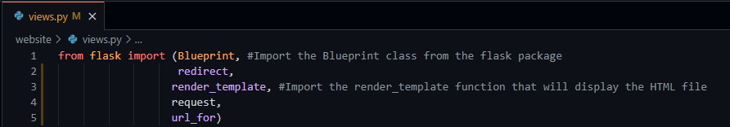

The redirect function allows me to redirect the user elsewhere, and the url_for function allows me to redirect to a specific view within my application, as seen below:

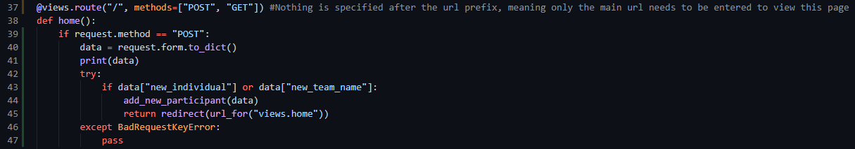

I return a redirect that early and will do at the end of every function because it prevents duplicate POST requests taking place, which prevents duplicate entries and possible crashes of the application.

Upon testing, the or statement will not work since the exception will be raised if “new_individual” does not exist, meaning it will not be able to reach “new_team_name”. This means that I will have to define them in separate statements as seen below.

### Deleting a participant:

This POST request is triggered by clicking the delete icon next to a participant’s name, and then clicking the confirmation delete button afterwards. The key that this request passes in is simply just “username”, and what I do is check the name that is passed with this key, against the individuals database, and if it doesn’t exist, check the teams database and delete it from there, and if it doesn’t exist in either database it will just return nothing, which does not error the program or harm the user in anyway.

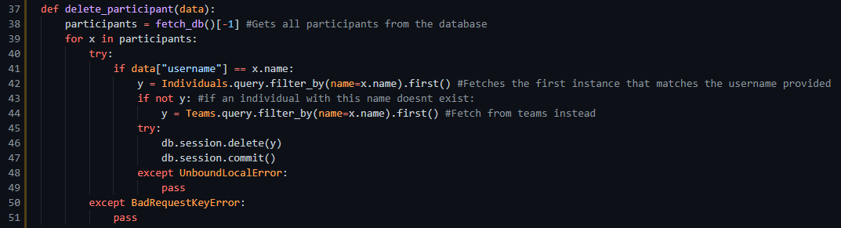

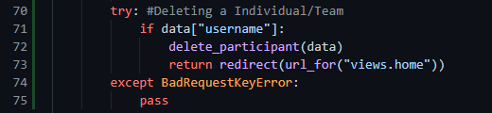

### Adding a score to a participant:

A user can add a score, as well as what event they played to a participant’s records, and in order to do this they need to click the “+” icon under the actions tab next to their name. The post request will send a dictionary containing 3 keys, one of which being called “event”, another being their “name”, and the other being called “points”. The way I decipher whether this particular event is being triggered or not is by checking for the “event” key, since it isn’t used in any other request. 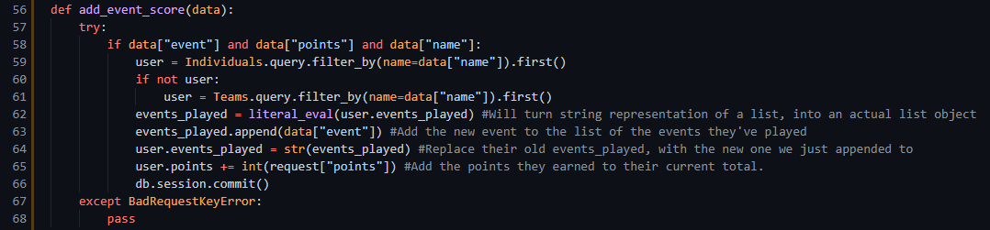

The cycle of this function is explained mainly in the comments accompanying the code. The only other change I have had to make for this piece in particular is doing “from ast import literal_eval” to allow me to turn a string representation of an object, into the actual object it represents. For example it will turn “[‘race 1’]” into an actual list, looking like [‘ race 1’]. Since the database will only accept strings, I need to convert it back to a string before committing it to the database.

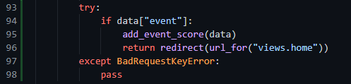

### Creating a new event:

Creating a new event is extremely simple, since unlike where we add a new participant, we don’t need to check whether it’s for a team or individual object – we simply call the Events object and create a new instance of one and commit it to the database.

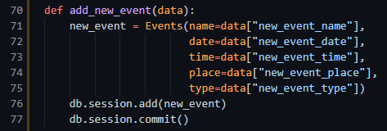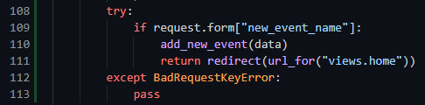

### Editing and deleting an existing event:

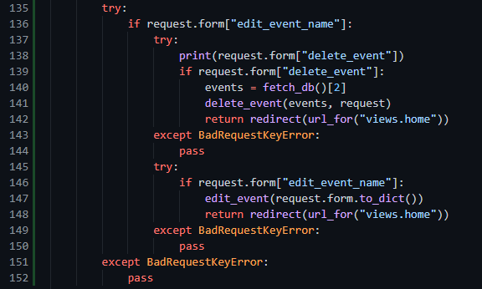For editing and deleting an event, it can prove to be slightly tricky since because they are in the same form, even when selecting the delete event button it will still POST a “edit_event_name” key, so I need to make sure I am checking for “delete_event” inside of a check for “edit_event_name”, this is to eliminate the chance of multiple functions being triggered since the request form keys are present no matter which one of the two buttons you click.

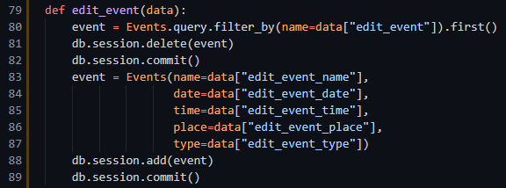

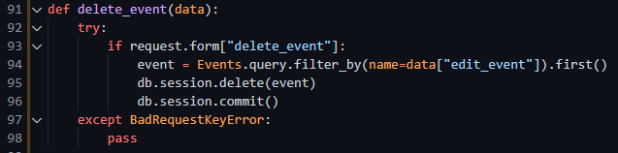

This concludes the back-end code for the home page. The functions mentioned in this section allow for the following:

* Adding an Individual Participant
* Adding a Team
* Deleting a Participant
* Adding a New Score to a Participant
* Adding a New Event
* Editing an Existing Event
* Deleting an Existing Event

### Handling Login Requests:

All that’s left to do is to handle login POST requests. This is the simplest of all the request handlers previously mentioned since it is simply checking 2 keys from the request form and checking it against the User table.

In order for this login request handler to function, I need to import a few new modules, including:

* Login_user from flask_login
* Check_password_hash from werkzeug.security

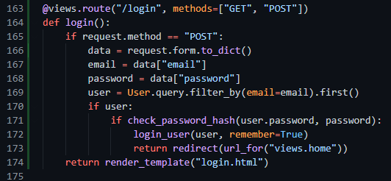

## Logging Out:

This is by far most definitely the simplest part of the back-end simply due to flask’s built-in login and logout functions that handle user accounts for you. In order to have a functioning logout route I need to define a new route called “/logout” which calls the flask_login logout function, and then redirect the user to the login page. Finally as one extra touch, in order to stop people from accessing the main page without being logged in, I will use another one of flask’s built-in functions that require the user to be logged in before they can access the home page.



Logout_user and login_required are the 2 new functions I have imported, login_required can be used as a decorator to stop the user from accessing the page without being logged in.

